**SSG E – VOTING SYSTEM USING LARAVEL FRAMEWORK IN BOHOL ISLAND STATE UNIVERSITY – BILAR CAMPUS**

______________

A Thesis

Presented to the Faculty

College of Technology and Allied Sciences

Department of Computer Science

BOHOL ISLAND STATE UNIVERSITY

Zamora Bilar, Bohol

______________

In Partial Fulfillment

of the Requirements for the Degree

in Bachelor of Science in Computer Science

______________

Mark Russel T. Baral

Marry Ann C. Gallebo

Romeo Luayon L. Jr.

**Chapter 1**

**THE PROBLEM AND ITS SCOPE**

**Rationale**

An election is a crucial event in the present government (Patil et al., 2018). The establishment of democracy in a community is accomplished through elections. It is also one of the most difficult tasks, and its challenges are remarkably severe (Suralkar et al., 2019). The election is also applied to various organizations such as the student council. The student council is the most significant and fundamental organization for providing the proper attention to the students regarding student service and academic issues and conveying them to the authority concerned (Teresa & Ciu, 2021).

According to the study by Celestine et al. (2018), e-voting is the term used to describe elections or voting procedures in which voting is done electronically. Other nations are also continuing to conduct electronic voting, such as those for student councils or youth councils, which have utilized it. Moreover, electronic voting, as opposed to traditional voting, is important since it considers how polling tasks can be performed electronically without affecting voter privacy or creating opportunities for fraud.

The primary subject of this research is the Supreme Student Government (SSG), one of the student organizations at Bohol Island State University – Bilar Campus. The SSG conducts an annual election, but the onset of the COVID-19 pandemic has had significant impacts on the university, including student government elections. The university had to adapt to the new normal to ensure the safety of the students. Since face-to-face classes were prohibited, the SSG election was conducted using Google Forms to collect votes from voters. However, this solution is not ideal, as the use of BISU email to access the election form cannot guarantee the honesty of the election. Students from other BISU campuses can access the link, which can lead to inefficiencies such as dishonesty and cheating.

Having identified the current problems with the SSG election process, the researchers designed an application software for Bohol Island State University – Bilar Campus to improve the voting system and came up with the idea of creating a web-based e-voting system using the Laravel framework. This system is easy to use, customizable, and capable of generating a report, and only BISU – Bilar students can access the election form. Moreover, Laravel is a secure framework that provides built-in protection against common web application security threats such as SQL injection and cross-site scripting (XSS) attacks (Ali, 2022). This can help prevent suspicious actors from injecting malicious data into the system and ensure the integrity of the voting process.

**Literature Background**

Based on Article V Section 1 of the 1987 Constitution of the Republic of the Philippines which states that:

"Science and technology are essential for national development and progress. The State shall give priority to research and development, invention, innovation, and their utilization; and to science and technology education, training, and services. It shall support indigenous, appropriate, and self-reliant scientific and technological capabilities, and their application to the country's productive systems and national life."

This article states that in addition to encouraging all organizations to utilize and innovate with science and technology, the state ought to acknowledge the use of building technologies. It is crucial that the government provide access to the most recent technology so that it can be such for societal changes and advancements. The developers developed an applicable e-voting system in Bohol Island State University – Bilar Campus. An ideal system that will enhance the voting process and provide security using the laravel framework of Bohol Island State University - Bilar Campus.

Another is on Edgar F. Codd's Relational Database Management System. According to Codd, a database must obey in order to be a true relational database. These rules can be applied to a database system that is capable of managing is stored data using only its relational capabilities. This is a standard method by which information is organized and retrieved from computers. The theory is based on the idea that the data will be manipulated by the user using interface tools (Codd, 1970).

To get a clearer understanding of how the project would be designed, these are several studies that have similarities to proposed E-Voting System.

1. E-Voting System Using Homomorphic Encryption Technique (Sheela et al., 2021). This e - voting system prevents manipulation while facilitating excellent dependability and authenticity. E-voting may be conducted using standalone electronic voting machines (also known as EVMs) or computers that are online, depending on the specific implementation. It could include a variety of Internet services, from simple results tabulation broadcast to fully functional online voting using commonly available gadgets. Using Zigbee technology and cryptographic apps, the data gathered from the election will be instantly relayed to the local database servers.
2. Mobile-based Student Council Voting System Case of Federal Technical Institute (FTI) (Teresa & Ciu, 2021). This voting system for student councils using mobile devices was primarily created for the Federal Technical Institute student council. The study discusses the benefits of the mobile-based student council voting method, which inspires various institutions and organizations to create applications for the system. It also conveys the major concerns that have to be taken into consideration during its development..
3. E-Voting Using Blockchain with Biometric Authentication (Suralkar et al., 2019). The primary objective of this study is to create an electronic voting system that is more secure, accurate and does not require as many reliable people to participate at every level. The developers strategize to use blockchain technology to make voting more secure, as well as ring signature and fingerprint authentication for added security.
4. E-Voting System for National Association of Computer Science Students Modibboadama University of Technology Yola, Adamawa State, Nigeria (Celestine et al., 2018). The primary goal of this study is to demonstrate the benefits of electronic voting over traditional voting methods in the National Association of Computer Science Students (NACOSS), MAUTECH, and YOLA. Focus group discussions and interviews were used to gather qualitative data, and RAD system analysis and design were used to implement the suggested system. The focus group discussion and interview results, which emphasized the limitations of the department's long-standing manual voting process, led the developers to advise that, if implemented, an e-voting system for the department would be more appropriate for the departmental elections.
5. An Online Voting System using Face Recognition for Campus Election (Sulaiman et.al., 2021). This research aimed to create a remote voting system that would be more convenient for voters to use on election day and would increase accessibility for students. The study uses facial recognition as a method of identification to confirm that voters are valid. This method would help students and organizers since it can be accessed from a distance, is reliable, practical, and shortens the voting process.

There are the related systems which use Laravel framework that are implemented in different organization and institution. Among these that are significant to this study are:

1. Design and Development of a Web-Based System using Laravel Framework: A Competition Management System (Azran & Wahid, 2022). The Agile Scrum Methodology is used to develop the system. Laravel, the PHP Framework, and the MariaDB database are all used in the creation of this system. At the conclusion of the project's development, testing revealed that the system had successfully complied with all functional requirements. According to the proposal diagram, each module has been implemented. This approach is anticipated to facilitate online competition management and attract more members to the digitalization community.
2. Management information systems of laboratory using laravel framework:case study at electrical engineering of Universitas Negeri Semarang (Zuhdi et al., 2017) This paper aims to discuss the development of a lab management information system that facilitates scheduling lab tasks more efficient, using the Electrical Engineering Laboratory of the University of Negeri Semarang as a case study. The information system was developed to make it simpler and more convenient for the Laboratory Chairman, Laboratory Institution of Education, and students to maintain records of laboratory activities, including data on lab work, voting laboratory scheduling data, lecturers' data, subjects' data, and electrical engineering lab data. The test results show that SIMLAB is suitable to be used within the electrical engineering laboratory at Universitas Negeri Semarang.
3. VISITOR MANAGEMENT SYSTEM USING LARAVEL PHP (Aruna & Kalaiselvi, 2018) In this study, the traditional method of manually recording each visitor's information has been replaced with a modern visitor management system that automates the entire process and allows the operator to know the overall number of visitors inside the premises. The system also includes a feature to look up or analyze prior visits made by the visitor, increasing visitor authentication.
4. Information System Management of Palm Agriculture using Laravel Framework (Alhari et al., 2022) In this study, the developers created a Laravel-based application for an agriculture information management system. This application's implementation phases employ an incremental iterative methodology and a number of specialized test cases. With the use of this application, it is intended that oil palm producers will have simple access to data and information as well as simple land management.
5. Smart Final Year Project Archive System Using Laravel Framework with Email Notification (SFYPAS) (MatTaib et al., 2020) reveals that the mean for user acceptance with TAM is 4.27, while perceived usefulness is 4.47 in terms of perceived ease of use. It demonstrates that the respondents are satisfied with the system in terms of how beneficial they think it is. In summary, the research has succeeded in its goals by making it easier for users to access previous FYP theses by offering a web-based smart archive system.

The development of these systems provides the foundation for developers to enhance the current method. This will support and direct the developers in their efforts to enhance the SSG electronic voting system at the bilar campus of the Bohol Island State University utilizing the Laravel framework.

.

**THE PROBLEM**

**Statement of the Problem**

The study aims to assess and develop an SSG E-Voting System using Laravel Framework in Bohol Island State University - Bilar Campus.

Specifically, it sought to answer the following questions:

1. What are the ways to improve the current voting platform process?
2. What are the problems that are encountered in the current process?
3. How to design and developed the system with the modules:
   1. Login
   2. Administration
   3. Record Voters
   4. Voting
   5. Tally
   6. Reports
4. What is the level of usability of the system?

**General Objective**

The main goal of the study is to design a system that will improve the existing voting platform of BISU Bilar Campus.

Specifically, the project aims the following objectives:

1. To develop a system that will improve the current platform.
2. To test and evaluate the developed system usability.
3. To implement the developed a web based e-voting system using laravel framework

**Scope and Limitation**

This study encompasses only the development and implementation of a web based e - voting system which secures a reliable election by undergoing a series of process.

1. **Acquisition** – This module includes the acquiring of data and recording of users, candidates, and votes.
2. **Administration** – This feature enables the management of users, access, and security while providing administrative tools for system maintenance and configuration.
3. **Reports** – The system generates reports on the results of the election and the new sets of elected officers.
4. **Online Mechanism** – This module allows the web-based electronic voting system using the Laravel Framework and a modular design that fulfills the system's requirements.

**Significance of the Study**

The proposed system will help the Bohol Island State University in their voting system and will lead them to the development of their Supreme Student Government in conducting election.

It will also give convenience to those people who will use the proposed system like the students and especially to the facilitators in terms of time consumption, reliability issues and hassles. The following individuals or group will benefit from the success of the project:

**Administrators. It refers to the person(s) who will be managing or in-charge of the student election, this project is a great help for them, it lessens their workload, the said system will provide them accurate reports needed.**

**The SSG (Supreme Student Government).** This study will reduce the effort and work of the SSG officers because the proposed system will automatically get the result of election.

**The University (Bohol Island State University - BISU).**The proposed system will provide efficient and secure election of the new student officers of the university.

**Students (Voters).**This system will provide accurate and security that can assure they will have an honest and accurate result of the election.

**Researchers**. The success of the study will highly contribute to their knowledge and skills in developing helpful programs.

**Future Researchers**. The study will serve as their guide if they wish to conduct the same study.

**RESEARCH METHODOLOGY**

**Development Framework**

The conceptual diagram of the SSG E – Voting System study is shown in Figure 1. It contains the fundamental operation of the system, which reflects the work of the admin, the sub-admin, and the voters. It shows the input-process-output (IPO) study model. The procedures include acquisition, voting, and reports. The result helps the admin in decision-making.

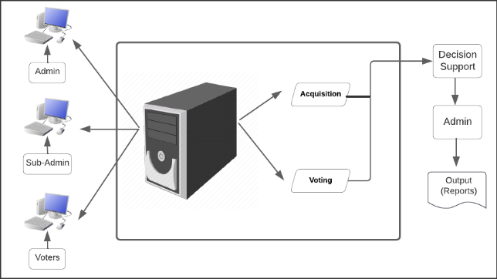

Figure 1. Conceptual Diagram of the Study

**Block Diagram**

The figure 2 shows the block diagram of the proposed SSG E – Voting System Using Laravel Framework in Bohol Island State University – Bilar Campus. It covers the specification of the basic functionality of the system that represents the work of admin, sub-admin and voters who will use the system through a wide area network.

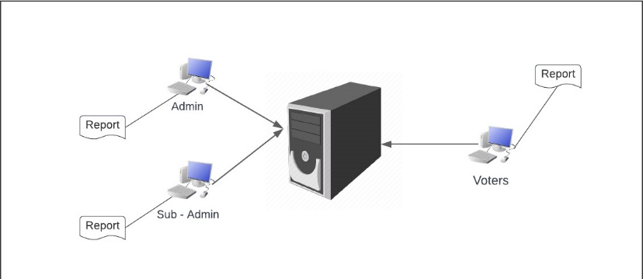

Figure 2. Block Diagram of the Study

**Development Model and Approaches**

Rapid Application Development is the approach that the researchers utilized (RAD). It is a development approach that places an emphasis on immediate feedback and rapid prototyping over extended development and testing cycles. Researchers may quickly iterate and update software through fast application development rather than having to start the development process overfrom scratch each time. Prototyping is a suitable way for gathering functional requirements if the clients are unable to express their needs and do not know what they want. It is ideal to construct a prototype so that people can see, touch, and feel the present system firsthand. This makes it much simpler for consumers to express their wishes and desires.

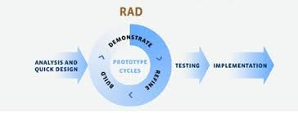 https://blog.capterra.com/what-is-rapid-application-development/

Figure 3. Rapid Application Development Model (RAD) Diagram

The development process follows the stages enumerated below with the corresponding activities taken:

**Analysis and Rapid Design**

Before the researchers considered how to solve the issue, they first assessed the present process, planned the design, and began implementing significant changes. When creating software, researchers must first understand the issue that the solution will try to solve. For the program to be effective, the researchers must comprehend the features, operations, behavior, and performance of the system. In the design stage, the solution's functionality is identified. After management has approved the software's structure, the program's architecture is now constructed. Identifying the system's anticipated requirements is the main objective of this stage.

**Prototype Cycle**

PHP was used as the server-side scripting language, the scripting language. To facilitate with testing and debugging, sample data was inserted into a database built using the MYSQL database engine. The construction of codes based on the specifications then started the programming operations. Typical programming practices such as data validation and error trapping were implemented into the system. The e – voting system's database management system was used for the centralized data storage.

**Testing Phase**

It is the next step after the prototype cycle. In this stage, the beta system will be presented to the establishment head and staff to make ensure that everything is functioning correctly and that the client's expectations and objectives are fulfilled.

**Implementation Phase**

The product will be deployed in the customer environment following the completion of initial and complete testing. A permission letter will be submitted for approval that the proposed system will be tested at Bohol Island State University – Bilar Campus.

The following were the tools used in the development of SSG E – Voting System using Laravel Framework of Bohol Island State University – Bilar Campus.

1. **Laravel Framework** we use laravel as our system’s main framework for our security, frontend and back end environment. Some of the features of Laravel are a modular packaging system with a dedicated dependency manager, different ways for accessing relational databases, utilities that aid in application deployment and maintenance, and its orientation toward syntactic sugar.
2. **PHP** is a general-purpose scripting language geared toward web development. we use PHP as the main language of the laravel framework for our backend development.
3. **JavaScript** is a programming language that is one of the core technologies of the World Wide Web, alongside HTML and CSS. We chose to use this as part of our frontend development, input validation, and The Document Object Model (DOM) manipulation.
4. **MySQL** is a relational database management system based on SQL – Structured Query Language. We used this to connect the data from the database to help generate reports from our current system.
5. **Visual Studio Code** is our chosen IDE that helps us programmers develop software code efficiently. It is a free, lightweight but powerful source code editor that runs on your desktop and on the web and is available for Windows, macOS, Linux, and Raspberry Pi OS.
6. **Cascading Style Sheets** (CSS) is a style sheet language used for describing the presentation of a document written in a markup language such as HTML or XML , we use this as an advance and more efficient in styling our website. CSS is a cornerstone technology of the World Wide Web, alongside HTML and JavaScript.
7. **Bootstrap 5** is the newest version of Bootstrap, which is the most popular HTML, CSS, and JavaScript framework for creating responsive, mobile-first websites. We use this as an easy and convenient inside HTML for styling and generating a ready to use responsive technology. It makes it possible for a web page or app to detect the visitor's screen size and orientation and automatically adapt the display accordingly.
8. **XAMPP** we used this to create a database server for the development of computerized system of Bohol Island State University – Bilar Campus.
9. **HTML** stands for Hyper Text Markup Language. HTML is the standard markup language for creating Web pages. HTML describes the structure of a Web page. HTML consists of a series of elements. HTML elements tell the browser how to display the content.

**Environment and Participants**

The study is conducted at Bohol Island State University – Bilar Campus in Zamora, Bilar, Bohol. The respondents for the study were the adviser of the Supreme Student Government and 10 students each from three different colleges: the College of Agriculture and Natural Resources (CANR), the College of Teacher Education (CTE), and the College of Technology and Allied Sciences (CTAS), for a total of 31 participants.

**Data Collection**

In gathering data for the study, the researchers asked permission by submitting a request letter to the SSG Adviser of the Supreme Student Government (SSG) of Bohol Island State University – Bilar Campus. Data was gathered through personal interview with the SSG adviser using the interview guide question in order to gather enough data and information needed in the study. The system design, which enables researchers to determine the system's general architecture, will be developed by checking at the requirements.

**OPERATIONAL DEFINITION OF TERMS**

The terminologies used or stated were further defined operationally in the study:

**SSG E-VOTING System Using Laravel Framework.** The system which will be developed to improve the processes of the BISU-Bilar SSG Organization Elections.

**Supreme Student Government (SSG).** The SSG refers to the highest governing body of a student organization in a school, college, or university which conducts an annual election and is the main focus of the study.

**Bohol Island State University – Bilar Campus.** The institution where the researchers conducted the study.

**SSG Adviser.** The adviser of the SSG who facilitates the overall process of the SSG election.

**Candidate.** The candidate refers to an individual who is running to be elected in a leadership position in the SSG to represent and serve the student body.

**Students.** The students are the voters who participate in the SSG election and cast a vote for their preferred candidate or party.

**Administration.** The one who manages or handles the confidentiality of the records of the system and the credentials of the users.

**Chapter 2**

**PRESENTATION OF FINDINGS, ANALYSIS AND INTERPRETATION OF DATA**

**Existing Operation and Processes**

The voting process of the Supreme Student Government (SSG) of Bohol Island State University - Bilar Campus uses Google Forms in order to conduct a SSG Election to gather votes from the voters. They make manual adjustments to the Google form to convert it into a platform for voting. In the distribution of the form link to the voters, the SSG Adviser sends the link to the voters to cast their votes. Moreover, the SSG adviser identifies the winners using the graphical charts in the Google Forms and link the results of the election in the Google Sheets. The present system involves different processes.

**A. Filing of Candidacy**

Students of Bohol Island State University – Bilar Campus who aspire to become SSG officers will need to visit the SSG office and file a candidacy for their desired positions. Aspiring candidates will need to submit the required documents, including the Candidacy Form, grades, Certificate of Registration, to qualify for candidacy. The SSG adviser will facilitate the validation and checking of these documents. Qualified students will be included in the official list of SSG candidates, and their documents will be stored in the Candidates Folder. The voters in the SSG Election are the officially enrolled students of BISU – Bilar Campus. The candidates will be given enough time to conduct their campaign and share their platforms to help voters to get to know them.

**B. Create Election Form**

The SSG adviser creates the election in the Google Forms by recording the needed data of the qualified candidates. The needed data are the candidate’s personal information such as name, year and course, department, college, position, and partylist. These are stored in the Google forms which will be the platform for the SSG election. The SSG adviser will share the link to the students in order to access during the election day.

**C. Voting Process**

The voting process of the SSG election is done in the Google Forms. The students will use the BISU email to access the link. Students can access the main form which displays the candidates for the national positions. There will be a section in the form which it asks the voters for their college and departments in order for the students to vote in the local positions. The voters will cast their votes to the candidates whom they think would fit for the positions. After the voting process, voters will submit the form. A feedback will be displayed after the submission. The Google form can be accessed within the alotted time duration and students can only vote once.

**D. Tally Process**

The forms that are successfully submitted to the Google Forms are seen in the Response section by the SSG adviser. The votes will be displayed in graphical charts with corresponding percentages. The candidates whom have the highest votes within the given time alloted for the election and based on the charts will be declared as the new elected SSG officers.

**D. Generation of Reports**

The results of the elections will be transferred by the SSG adviser to Google sheets and word document files. He will submit the official list of the newly elected candidates to the Students Affairs Services Director and will inform the students through a Facebook post for the official results.

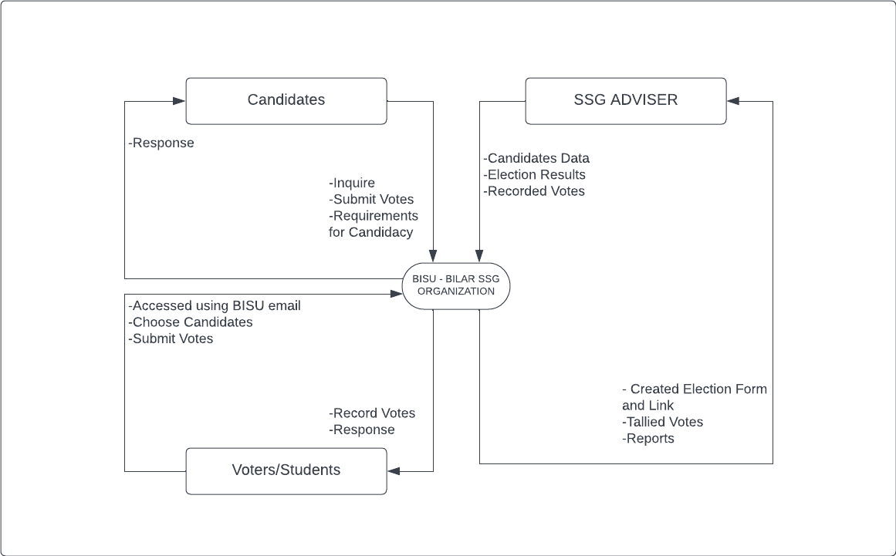

Figure 4. Context Diagram of the Present System of Loboc Tourism

**EVENT SPECIFICATION**

**Event List**

1. Inquiry Process

2. Create Election Form

3. Voting Process

4. Vote Counting Process

5. Generation of Reports

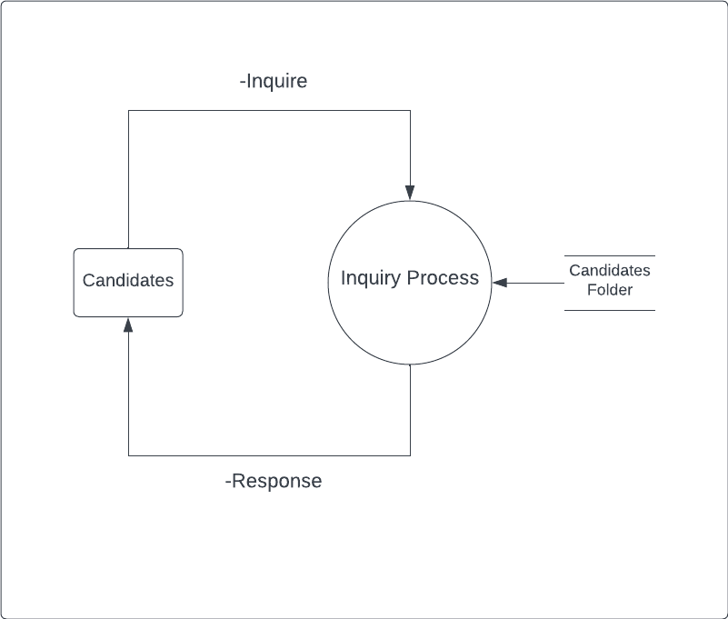

Figure 5. Inquiry Process (Event 1)

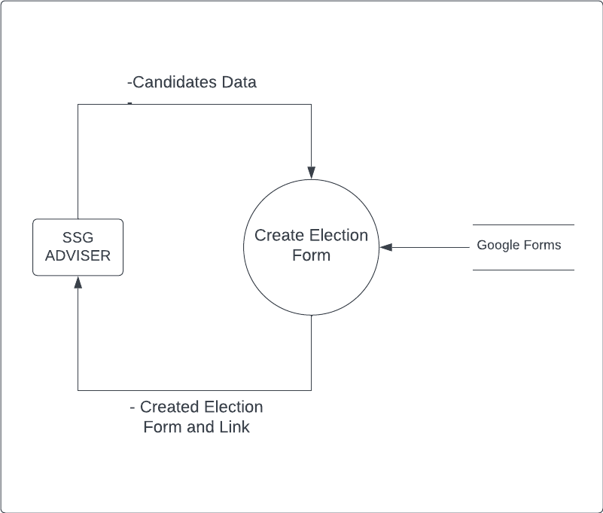

Figure 6. Create Election Form (Event 2)

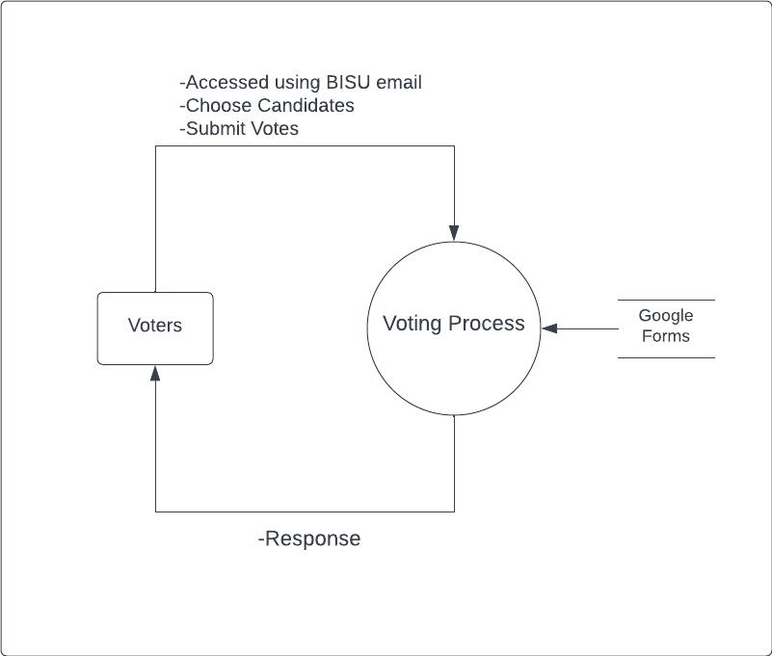

Figure 7. Voting Process (Event 3)

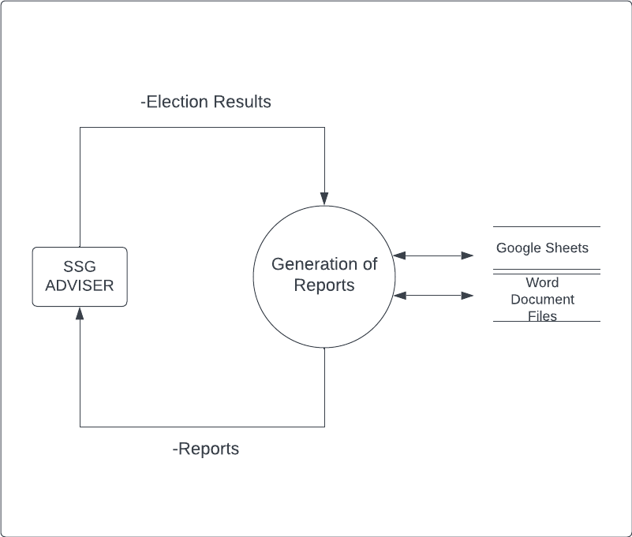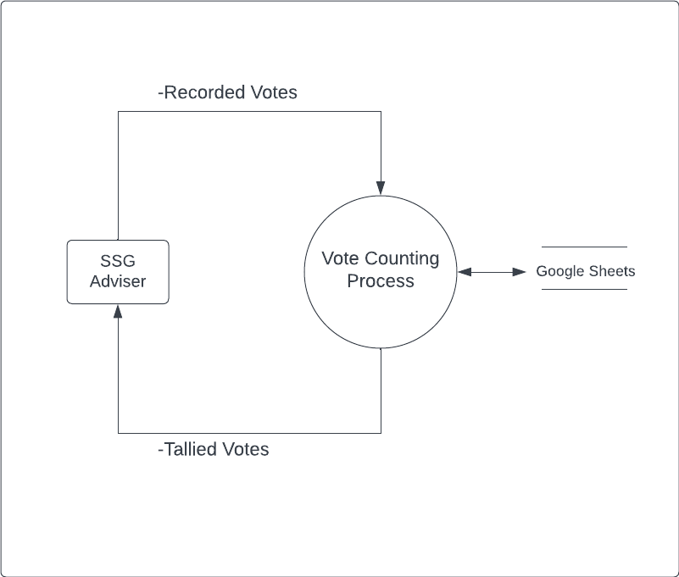

Figure 9. Generation of Reports(Event 5)

Figure 8. Voting Counting Process (Event 4)

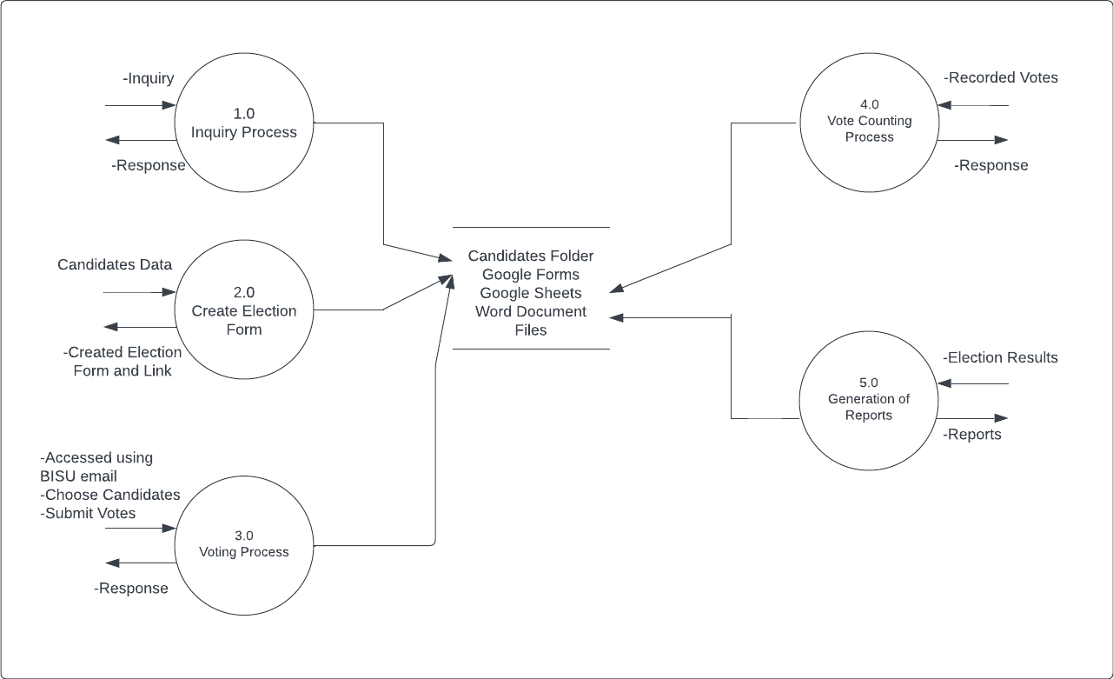

Figure 10. Top Level of the Present System

**Needs of the Existing Operation**

The present system of the SSG election of Bohol Island State University - Bilar Campus needs significant procedures to ensure that the voting system is accurate, effective, and efficient.

The following are the requirements to improve the existing system of the Supreme Student Government (SSG) of Bohol Island State University – Bilar Campus.

* 1. Secured system to prevent unathorized person from accessing sensitive data and tampering with the election results. This supports maintaining the accuracy of the results and the integrity of the election.
  2. Web-based electronic voting system that is accessible to all the students and eliminates long waiting time.
  3. Provide simple user interfaces and are easy to use.
  4. Generates the credible election reports.

**SSG E-Voting System Using Laravel Framework in BISU Bilar Campus**

The needs of the present system serve as the basis for the development of the features of the SSG E-Voting System in BISU Bilar Campus. This study was expected to address the problems encouraged in the present system.

1. **Administration**

The SSG Adviser will log in as an admin with unlimited access to the system and also the SSG Staff with limited access to the system. Username and password must be entered values match in the database and the user may now access the system

1. **Recording of Voter’s Profile**

Newly registered voters will be added to the system and stored in the voters.tbl. Additionally, their ISMIS ID will be inputted for identification purposes.

1. **Recording of Candidate’s Profile**

The candidates, along with their desired position and party list, will be added to the system and stored in the candidates.tbl.

1. **Polling Commencement**

After the candidate data has been prepared, the initiation of the election is the duty of the SSG adviser. Access to the system will not be granted to voters until the SSG adviser commences the election. This responsibility of initiating the election solely belongs to the SSG adviser.

1. **Voting Process**

Before a voter can cast their vote, they need to be authenticated to ensure that they are eligible to vote. This can be done by requiring them to log in using their unique ISMIS ID. Once the voter is authenticated, the system will display the ballot with the list of candidates and their corresponding positions. The voter can then select their preferred candidate for each position. After the voter has made their selection for each position, the system will record their votes and tally them automatically.

1. **Generation of Reports**

The SSG Adviser will use the system to produce the election results showing the list of candidates, their positions, and the vote count.

**Use Case Diagram**

In software engineering, a use case is a list of actions or event steps typically defining the interactions between a role (known in the Unified Modeling Language as an actor) and a system to achieve a goal. The actor can be human or other external system. The detailed requirements ay then be captued in the Systems Modeling Language (SysML) or as contractual statements.

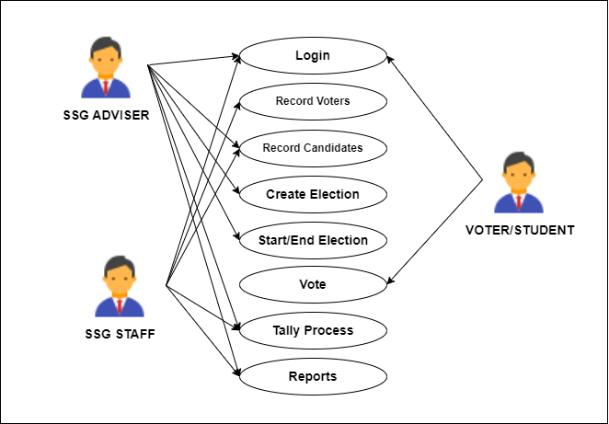

Figure 11. Use Case Diagram of SSG- E-Voting Sytem Using Laravel Framework of Bohol Island State University Bilar Campus

**Use Case Narrative**

**Table 1. Use Case Narrative 1 – Login Account**

|  |  |
| --- | --- |
| **Login (UC1)** | |
| **Scope** | SSG E – Voting System |
| **Level** | User goal |
| **Goal in context** | To give access to the system |
| **Primary Actor** | SSG Adviser |
| **Stakeholders** | SSG Adviser wants to access the system |
| **Preconditions** | SSG Adviser will login to the system |
| **Triggers** | SSG Adviser decide to login |
| **Success Guarantee** | SSG E – Voting System will grant access for the selected user |
| **Scenarios:** | |
| 1. SSG Adviser select the function “Login” 2. The system displays the Dashbboard | |

**Table 2. Use Case Narrative 2 – Record Voters**

|  |  |
| --- | --- |
| **Record Voters (UC2)** | |
| **Scope** | SSG E – Voting System |
| **Level** | User goal |
| **Goal in context** | To enable the SSG Adviser and SSG Staff to add a voter |
| **Primary Actor** | SSG Adviser, SSG Staff, Voter |
| **Stakeholders** | The SSG Adviser wants to register the voter so that the voter can vote |
| **Preconditions** | The user should be able to access the system and have the necessary privileges to add a voter. |
| **Triggers** | The SSG Adviser decides to adds a new voter |
| **Success Guarantee** | SSG E – Voting System successfully adds the new voter |
| **Scenarios:** | |
| 1. SSG Adviser select the function “voter” 2. The system displays the the list of voters | |

**Table 3. Use Case Narrative 3 – Record Candidates**

|  |  |
| --- | --- |
| **Record Candidates (UC3)** | |
| **Scope** | SSG E – Voting System |
| **Level** | User goal |
| **Goal in context** | To enable the SSG Adviser and SSG Staff to add a voter |
| **Primary Actor** | SSG Adviser, SSG Staff |
| **Stakeholders** | The SSG Adviser wants to register the candidates with their desired positions |
| **Preconditions** | The user should be able to access the system and have the necessary privileges to add a candidate. |
| **Triggers** | The SSG Adviser decides to adds a new candidate |
| **Success Guarantee** | SSG E – Voting System successfully adds the new candidate |
| **Scenarios:** | |
| 1. SSG Adviser select the function “candidate” 2. The system displays the the list of candidates | |

**Table 4. Use Case Narrative 4 – Create Election**

|  |  |
| --- | --- |
| **Create Election (UC4)** | |
| **Scope** | SSG E – Voting System |
| **Level** | User goal |
| **Goal in context** | To enable the SSG Adviser to create an Election |
| **Primary Actor** | SSG Adviser |
| **Stakeholders** | The SSG Adviser wants to create an election |
| **Preconditions** | The user should be able to access the system and can create an election |
| **Triggers** | The SSG Adviser decides to create an election if the candidates data are ready |
| **Success Guarantee** | SSG E – Voting System successfully create an election |
| **Scenarios:** | |
| 1. SSG Adviser select the function “create election” 2. The system displays the name of the election that should be modified | |

**Table 5. Use Case Narrative 5 – Start/End Election**

|  |  |
| --- | --- |
| **Start/End Election (UC5)** | |
| **Scope** | SSG E – Voting System |
| **Level** | User goal |
| **Goal in context** | To enable the SSG Adviser to start or end an election |
| **Primary Actor** | SSG Adviser |
| **Stakeholders** | The SSG Adviser wants to start or end the election |
| **Preconditions** | The user should be able to access the system and have the necessary privileges to start or end the election. |
| **Triggers** | The SSG Adviser decides to start if the candidates' data is ready and end if the election is done |
| **Success Guarantee** | SSG E – Voting System successfully start/end the election |
| **Scenarios:** | |
| 1. SSG Adviser select the button “start/end election” 2. The system should response after it select the button | |

**Table 6. Use Case Narrative 6 – Vote**

|  |  |
| --- | --- |
| **Vote (UC6)** | |
| **Scope** | SSG E – Voting System |
| **Level** | User goal |
| **Goal in context** | To enable voters to vote their desired candidates |
| **Primary Actor** | Voter |
| **Stakeholders** | The Voter wants to vote their desired candidates |
| **Preconditions** | The user should be able to access the system and have the necessary privileges to vote. |
| **Triggers** | The voters decided to vote and choose their desired candidates |
| **Success Guarantee** | SSG E – Voting System successfully recorded the votes |
| **Scenarios:** | |
| 1. Voter select the function “Login” 2. The system displays the candidates and their position | |

**Table 7. Use Case Narrative 7 – Reports**

|  |  |
| --- | --- |
| **Reports (UC7)** | |
| **Scope** | SSG E – Voting System |
| **Level** | User goal |
| **Goal in context** | 1. To provide an accurate report os the system 2. To generate reports to be view by SSG Adviser and SSG Staff |
| **Primary Actor** | SSG Adviser, SSG Staff |
| **Stakeholders** | 1. The user wants to have a faster generating of reports 2. The user want to generate accurate reports |
| **Preconditions** | The SSG Adviser will view the reports about voter information data |
| **Triggers** | The SSG Staff need to view the accurate reports of the election results |
| **Success Guarantee** | SSG E – Voting System allows the SSG Adviser and SSG Staff to view the current reports of the voter |
| **Scenarios:** | |
| 1. The SSG Adviser and SSG Staff select the function “Report” and view the current report of the voter and election result 2. The system displays the accurate data of the voter and election result | |

**Class Diagram**

Figure 10 below shows the class diagram of the develop SSG E – Voting System of Bohol Island State University Bilar Campus. This describes the structure of a system by showing the systems classes, their attributes, operations and relationships

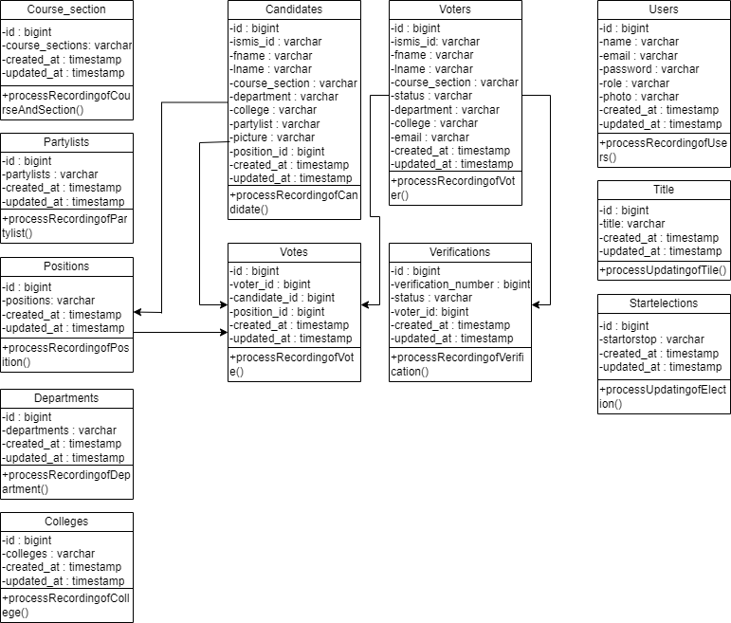

**Database Structure**

The following are the database tables that used in storing the information that are inputted in the system together with a collection of operations that facilitate searching, sorting recombination and of similar activities.

Table 1

Data Structure used for storing a new user

|  |  |  |  |  |
| --- | --- | --- | --- | --- |
| **Field** | **Fieldname** | **Type** | **Width** | **Description** |
| 1  2  3  4  5  6  7  8 | Id  Name  Email  Password  Role  Photo  Created_at  Updated_at | BigInt  Varchar  Varchar  Varchar  Varchar  Varchar  Timestamp  Timestamp | 20  255  255  255  255  255 | User ID  User Name  User Email  User Password  User Role  User Photo |

Table 2

Data Structure used for storing a new voter

|  |  |  |  |  |
| --- | --- | --- | --- | --- |
| **Field** | **Fieldname** | **Type** | **Width** | **Description** |
| 1  2  3  4  5  6  7  8  9  10  11 | Id  Ismis_Id  Fname  Lname  Course_section  Status  Department  College  Email  Created_at  Updated_at | BigInt  Varchar  Varchar  Varchar  Varchar  Varchar  Varchar  Varchar  Varchar  Timestamp  Timestamp | 20  255  255  255  255  255  255  255  255 | Voter ID  Voter Ismis_Id  Voter Firstname  Voter Lastname  Voter Course and Section  Voter Status  Voter Department  Voter College  Voter Email |

Table 3

Data Structure used for storing a new candidate

|  |  |  |  |  |
| --- | --- | --- | --- | --- |
| **Field** | **Fieldname** | **Type** | **Width** | **Description** |
| 1  2  3  4  5  6  7  8  9  10  11  12 | Id  Ismis_Id  Fname  Lname  Course_section  Department  College  Partylist  Picture  Position_Id  Created_at  Updated_at | BigInt  Varchar  Varchar  Varchar  Varchar  Varchar  Varchar  Varchar  Varchar  BigInt  Timestamp  Timestamp | 20  255  255  255  255  255  255  255  255  20 | Candidate ID  Candidate Ismis_Id  Candidate Firstname  Candidate Lastname  Candidate Course and Section  Candidate Department  Candidate College  Candidate Partylist  Candidate Picture  Candidate Position_Id |

Table 4

Data Structure used for storing a new college

|  |  |  |  |  |
| --- | --- | --- | --- | --- |
| **Field** | **Fieldname** | **Type** | **Width** | **Description** |
| 1  2  3  4 | Id  Colleges  Created_at  Updated_at | BigInt  Varchar  Timestamp  Timestamp | 20  255 | College Id  College Name |

Table 5

Data Structure used for storing a new course and section

|  |  |  |  |  |
| --- | --- | --- | --- | --- |
| **Field** | **Fieldname** | **Type** | **Width** | **Description** |
| 1  2  3  4 | Id  Course_sections  Created_at  Updated_at | BigInt  Varchar  Timestamp  Timestamp | 20  255 | Course and Section Id  Course and Section Name |

Table 6

Data Structure used for storing a new department

|  |  |  |  |  |
| --- | --- | --- | --- | --- |
| **Field** | **Fieldname** | **Type** | **Width** | **Description** |
| 1  2  3  4 | Id  Departments  Created_at  Updated_at | BigInt  Varchar  Timestamp  Timestamp | 20  255 | Department Id  Department Name |

Table 7

Data Structure used for storing a new partylist

|  |  |  |  |  |
| --- | --- | --- | --- | --- |
| **Field** | **Fieldname** | **Type** | **Width** | **Description** |
| 1  2  3  4 | Id  Partylists  Created_at  Updated_at | BigInt  Varchar  Timestamp  Timestamp | 20  255 | Partylist Id  Partylist Name |

Table 8

Data Structure used for storing a new position

|  |  |  |  |  |
| --- | --- | --- | --- | --- |
| **Field** | **Fieldname** | **Type** | **Width** | **Description** |
| 1  2  3  4  5 | Id  Positions  VoteLimit  Created_at  Updated_at | BigInt  Varchar  Varchar  Timestamp  Timestamp | 20  255  255 | Position Id  Position Name  Vote Limit |

Table 9

Data Structure used for updating an election title

|  |  |  |  |  |
| --- | --- | --- | --- | --- |
| **Field** | **Fieldname** | **Type** | **Width** | **Description** |
| 1  2  3  4 | Id  Title  Created_at  Updated_at | BigInt  Varchar  Timestamp  Timestamp | 20  255 | Title Id  Election Title |

Table 10

Data Structure used for storing a vote count

|  |  |  |  |  |
| --- | --- | --- | --- | --- |
| **Field** | **Fieldname** | **Type** | **Width** | **Description** |
| 1  2  3  4  5  6 | Id  Voter_Id  Candidate_Id  Position_Id  Created_at  Updated_at | BigInt  BigInt  BigInt  BigInt  Timestamp  Timestamp | 20  20  20  20 | Title Id  Voter Id  Candidate Id  Position Id |

**Program Hierarchy**

A program hierarchy of the developed system is a chart which was shown below its breakdown of the system ot its lowest manageable levels. Each table is represented by a box, which contains the module’s name. The hierarchy visualized the relationship between modues. As a design tool, it assists the programmer in dividing and conquering a complex software problem, that is, iteratively breaking down into parts small enough for a human brain to understand.

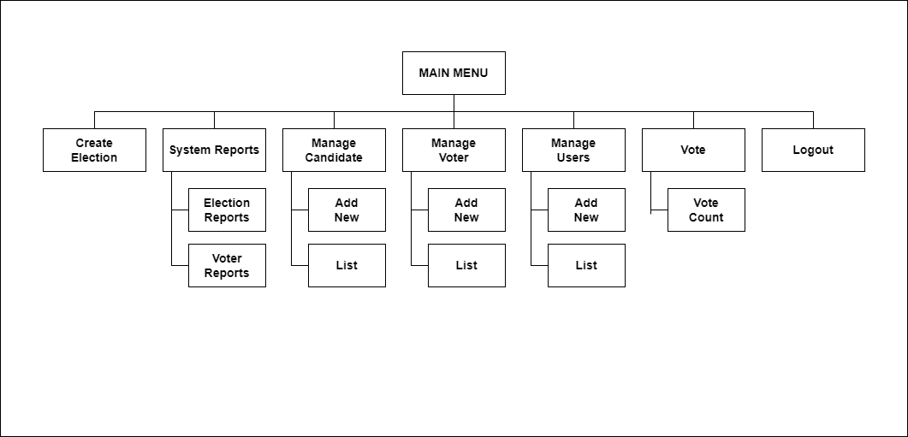

**Functional Requirements**

The functional requirements was the formulation with the use of the prototype in eliciting capture requirement through contrast communication with the SSG Adviser, SSG Staff and Voter. The function mentioned are based on the existing standard requirement of BISU BILAR Voting Process with the approval and coordination from the respondents as follows:

**Access to the system:**

FREQ 1: Access to the system must be password secured.

FREQ 2: All data data shall have a secure environment limiting access to authorized person only.

FREQ 3: The system should allow the SSG Adviser and SSG Staff to gain access to management of voter and candidate record.

FREQ 4: The system should allow the the voter to view the candidates data

**Candidate Records**

FREQ 5: The system should allow the SSG Adviser and SSG Staff to manage the candidate records.

**Voter Records**

FREQ 6: The system should allow the SSG Adviser and SSG Staff to manage the voter records.

**Create Election**

FREQ 7: The system should allow the SSG Adviser to create an election

**Process of Voting:**

FREQ 8: The system should provide a user-friendly interface for voters to cast their votes securely and efficiently.

FREQ 9: The system should prevent voters from casting multiple votes or changing their votes after they have been submitted.

FREQ 10: The system should allow the SSG Adviser and SSG Staff to monitor the voting process to ensure its integrity.

**Process of generating reports:**

FREQ 11: The system should provide a reports for the administration

**NON-FUNCTIONAL REQUIREMENTS**

A non-functional requirement is a set of criteria that can be used to evaluate

the operation system. Instead of specific behavior Functional requirements, on the

other hand, describe specified behavior of functions. The system should be simple

to use.

NFREQ 16: The system should be easy to use in Wide Area Network

Scheme.

NFREQ 17: The system should be user friendly and free from errors.

**Test Cases**

A test case is a set of conditions or variables under a tester will determine whether an application or software system is working properly or not, a detailed procedure that fully tests an attribute or an aspect of a failure. It is also a set of input values, execution, preconditions, expected results and executions, created for a particular objective or test condition, such as to exercise a certain program path or to verify compliance with a specific requirement.

These are the test case scenarios conducted during the acceptance testing. The text plain is to let the users use the system and follow the instructions in each test case to test the proposed system. The system should perform the expected result in each test case to be considered successful.

The following are the details of each test case:

**Test Case 1:**

Module: Admin Login Form

Instructions:

1. On the log in form type select user then enter username and password.
2. System will prompt the error message if the username and password are incorrect.
3. Input the correct username and password. Then click the option “Login”

button.

Expected Result:

• Main form will show

**Test Case 2:**

Module: Adding voters Information in voters module

Instructions:

1. Click “Add Voter”
2. Fill up all the blank data form
3. Then, Click “Save” button to save the filled out form

Expected Result:

• New Voter has been added

**Test Case 3:**

Module: Adding candidates Information in candidates module

Instructions:

1. Click “Add Candidate”
2. Fill up all the blank data form
3. Then, Click “Save” button to save the filled out form

Expected Result:

• New Candidate has been added

**Test Case 3:**

Module: Adding users information in users module

Instructions:

1. Click “Add User”
2. Fill up all the blank data form
3. Then, Click “Save” button to save the filled out form

Expected Result:

• New User has been added

**Test Case 4:**

Module: Adding positions in positions module

Instructions:

1. Click “Add Position”
2. Fill up all the blank data form
3. Then, Click “Save” button to save the filled out form

Expected Result:

• New Position has been added

**Test Case 5:**

Module: Adding course and section in course and section module

Instructions:

1. Click “Add Course and Section”
2. Fill up all the blank data form
3. Then, Click “Save” button to save the filled out form

Expected Result:

• New Course and section has been added

**Test Case 6:**

Module: Adding partylist in partylist module

Instructions:

1. Click “Add partylist”
2. Fill up all the blank data form
3. Then, Click “Save” button to save the filled out form

Expected Result:

• New partylist has been added

**Test Case 7:**

Module: Adding department in department module

Instructions:

1. Click “Add department”
2. Fill up all the blank data form
3. Then, Click “Save” button to save the filled out form

Expected Result:

• New department has been added

**Test Case 8:**

Module: Adding college in college module

Instructions:

1. Click “Add college”
2. Fill up all the blank data form
3. Then, Click “Save” button to save the filled out form

Expected Result:

• New college has been added

**Test Case 9:**

Module: Election Title

Instructions:

1. Click “Add Edit Election”
2. Edit the election tittle
3. Then, Click “Save” button

Expected Result:

• Election title successfully updated

**Test Case 10:**

Module: Start Election

Instructions:

1. Click “Start Election Button”

Expected Result:

• Election successfully started

**Test Case 11:**

Module: Stop Election

Instructions:

1. Click “Stop Election Button”

Expected Result:

• Election successfully stopped

**Test Case 10:**

Module: Voter Login Form

Instructions:

1. On the log in form enter ISMIS ID.
2. System will prompt the error message if the username and password are incorrect.
3. Input the correct username and password. Then click the option “Login”

button.

Expected Result:

• Voter form will show

**Test Case 11:**

Module: Submit Votes

Instructions:

1. Choose candidate using checkbox.
2. Submit votes after choosing a candidate

button.

Expected Result:

• Vote count successfully recorded

**Test Case 12:**

Module: Reports

Instructions:

1. Click “Print Button”.

Expected Result:

• Generate an election report of all candidates.

**Technical Requirements**

The innovation of the computer arises as an important part of the learning experience in business, education, government, and leisure. It allows everyone to be an effective and active participant in the emerging of computer technology. It also enables the user to various programs and software.

Appropriate selection of hardware and software components as well as the identification of people are involved in the operation. It is important for proper usage so that the system could be used to its fullest capacity.

The hardware component refers to the physical part of the computer processing unit (CPU). This includes the lower casing, microprocessor, hard disk, RAM, UPS, monitor, mouse, and keyboard. Though, there were only three components that facilitate the processing of data. These are the microprocessor, hard disk drive, and the Random Access Memory.

The software component refers to the program that the machine can read and perform with desired instruction. It is a set of instruction which the computer translates into a machine-readable format so that it can be manipulated besides, the software produces an output that can be understood by a human

Peopleware refers to the users who would operate the program and those who are involved in the system. The users must be capable of operating the system to have an efficient result in processing information.

**Minimum Hardware Specification**

This covers the minimum hardware specification that is highly needed by the system to function properly as intended and expected. These specifications were based on what is available in the market and what most computer package system offers.

|  |  |
| --- | --- |
| **Component** | **Specification** |
| Microprocessor  Hard Disk Drive  Random Access Memory (RAM)  Graphics Card | Inter Celeron 1.40 GHz  280 Gigabytes  2 Gigabytes  256-1 Gigabytes |

**Minimum Software Specification**

The SSG E – Voting System in the Bohol Island State University Bilar Campus requires various software to function properly. The specification as provided were based on the specification of the computer units utilizing during the development of the system. These software were listed below with its corresponding specifications

|  |  |
| --- | --- |
| **Item** | **Specification** |
| Operating System  Internet browser  Xampp  MySQL | Windows 10  Any internet browser  Version 2.4.9  Version 5.6.17 |

**Business Intelligence Integration**

Business Intelligence (BI) refers to the technologies, tools, and practices that collect, integrate, analyze and present large volumes of information to enable better decision making. It is a set of theories, methodologies, processes, architecture, and technologies that transform raw data into meaningful and useful information for business purposes. It aims to support business technique and decision making with a solution that takes the business intelligence to a whole new level and getting the like information. The system uses enterprises reporting particularly tabular type specifically in query and in reporting component. Each report is generated by joining more than one table in the connectivity of the database. This is to ensure the accuracy and consistency of the data in the report. All the reports below will change and update in real-time if there is any transaction to be done by the users.

There are reports on the next page taht represent how the business intelligence is applied in the developed system. This includes the following: Preview 1 which is the employee Report by type, Preview 2 which is the employee personal training, Preview 3 which is the leave and travel transaction report, Preview 4 which is the employee individual leave credit and Preview 5 which is the employee reports by departments.

The preview below shows the candidates report by vote count

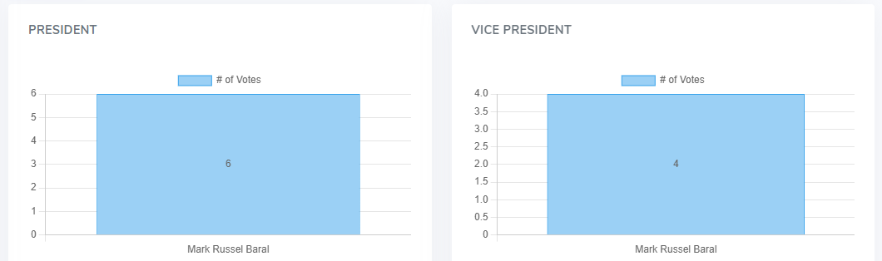

Preview 1. Candidate’s votes report

The preview below shows the election results



Preview 2. Election reults

**Screen Layout**

Screen layout is one of the many attributes of the system’s user friendliness.

The preview below shows the SSG Adviser and SSG Staff login form to acces the main form of the System

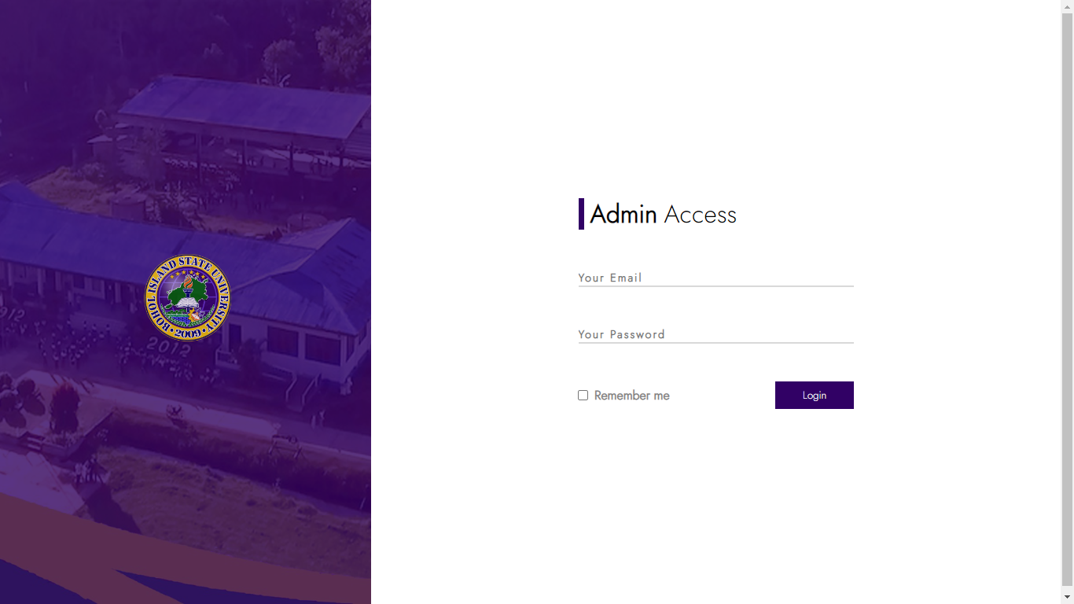

Preview 3. Admin’s Login Form

The preview below shows the dashboard of the System

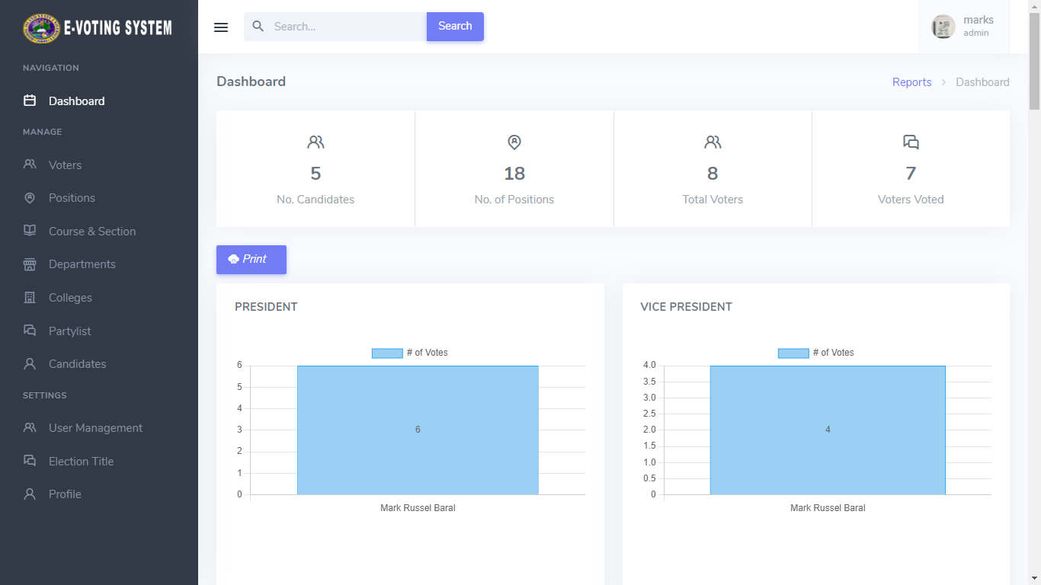

Preview 4. Admin’s Dashboard

The preview below shows the adding of Voters Information

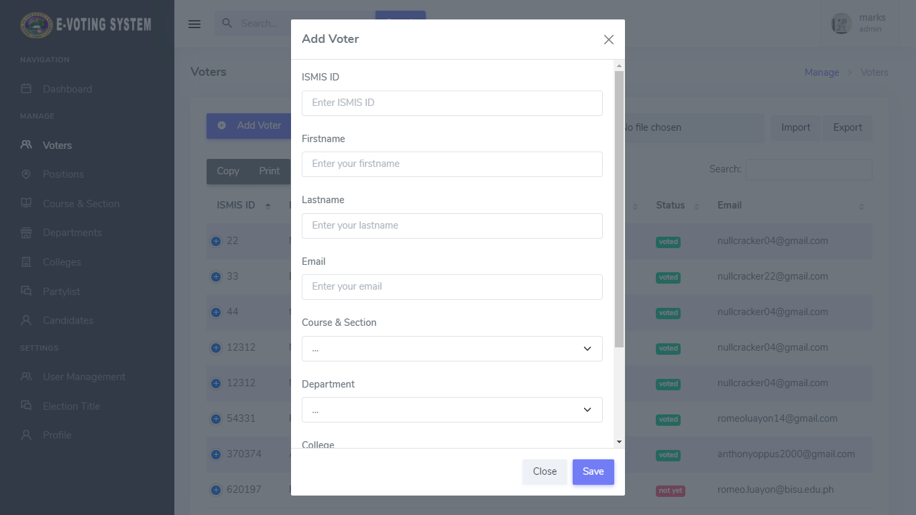

Preview 5. Adding Voters Information Form

The preview below shows the List of All Voters

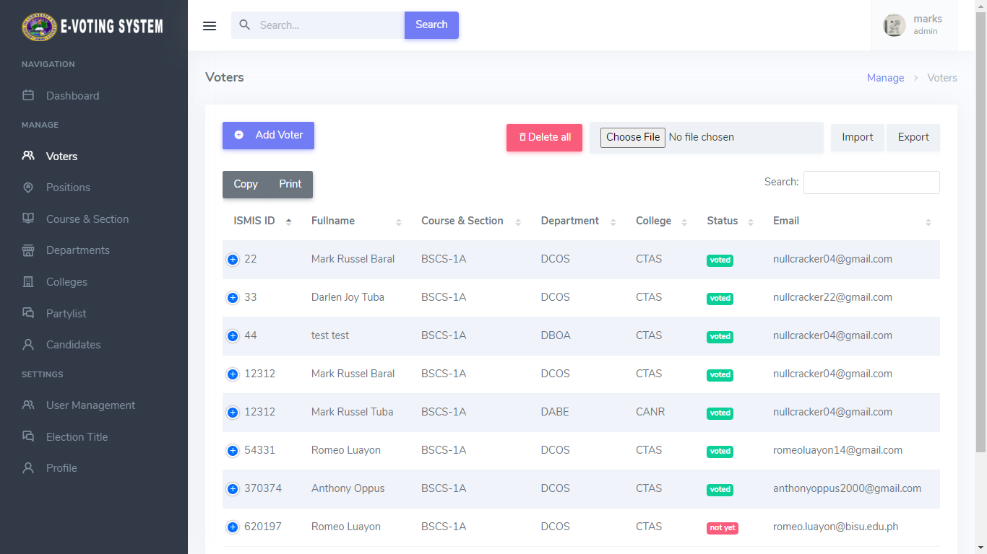

Preview 6. List of Voters

The preview below shows the Update Form of Voters Information

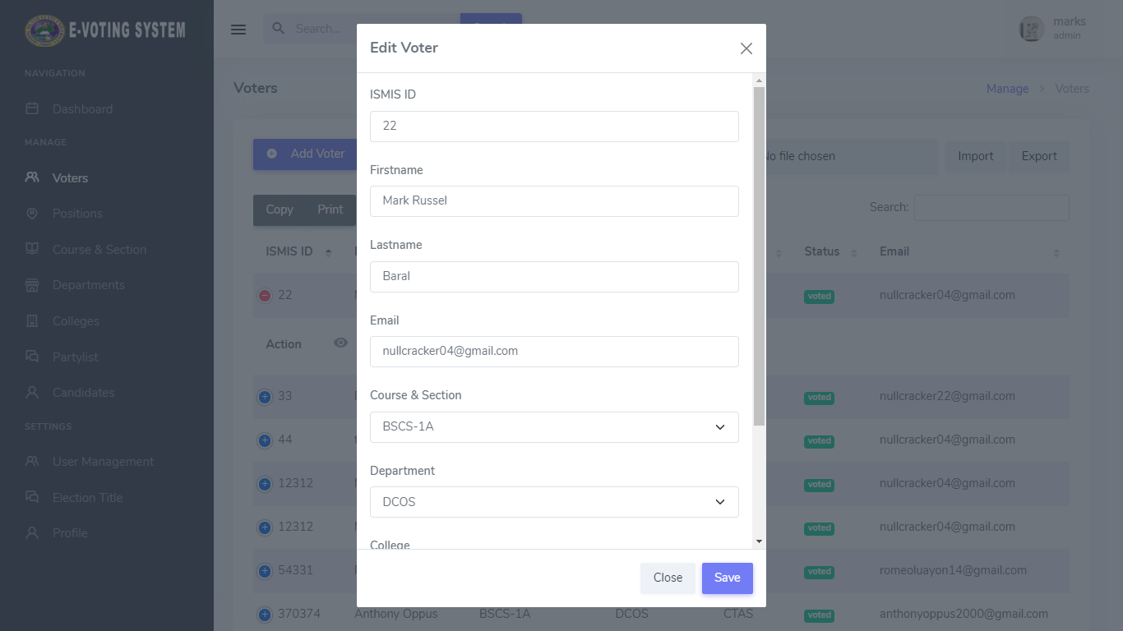

Preview 7. Update Form for Voters

The preview below shows the adding of Candidate’s Position

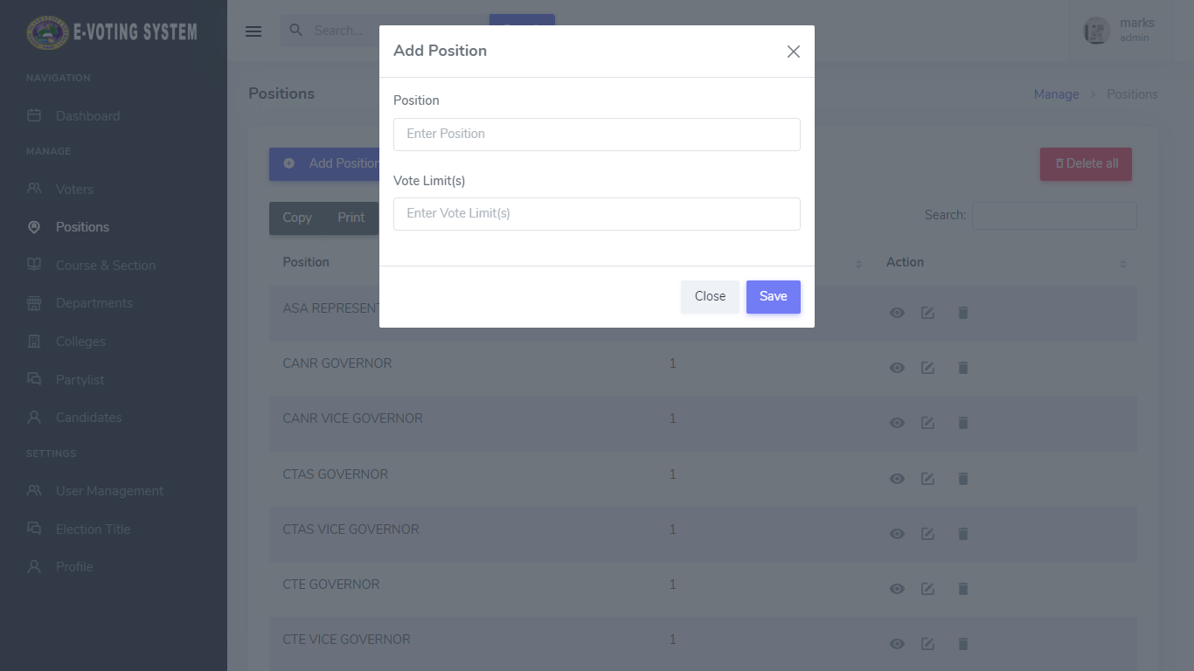

Preview 8. Adding Candiate’s Position Form

The preview below shows the List of All Candidate’s Positions

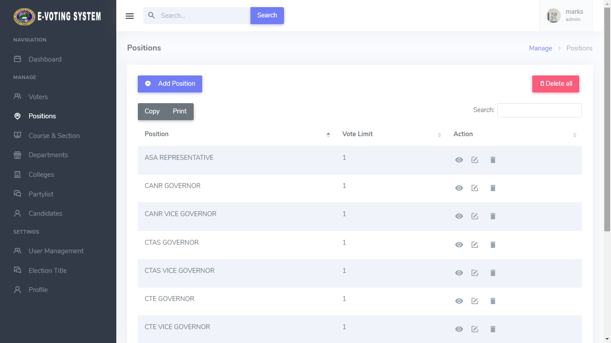

Preview 9. List of Candidates Position

The preview below shows the Update Form of Candidates Position

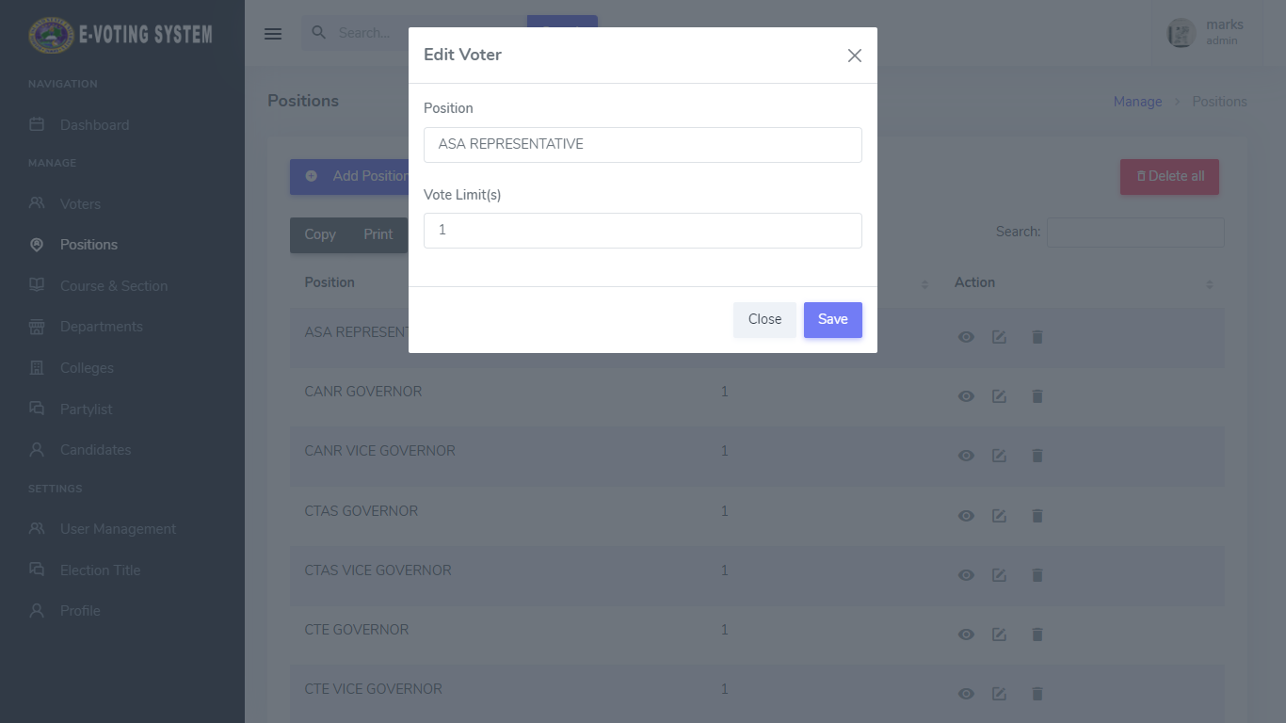

Preview 10. Update Form for Candidates Position

The preview below shows the adding of Voter’s Course and Section

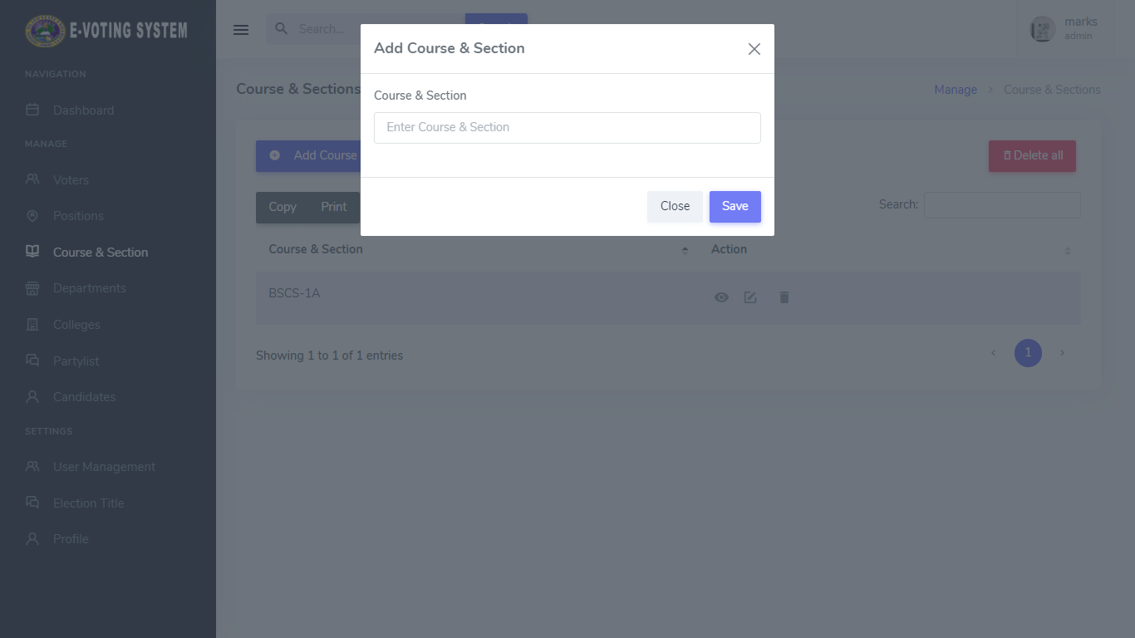

Preview 11. Adding Voter’s Course and Section Form

The preview below shows the List of All Voter’s Course and Section

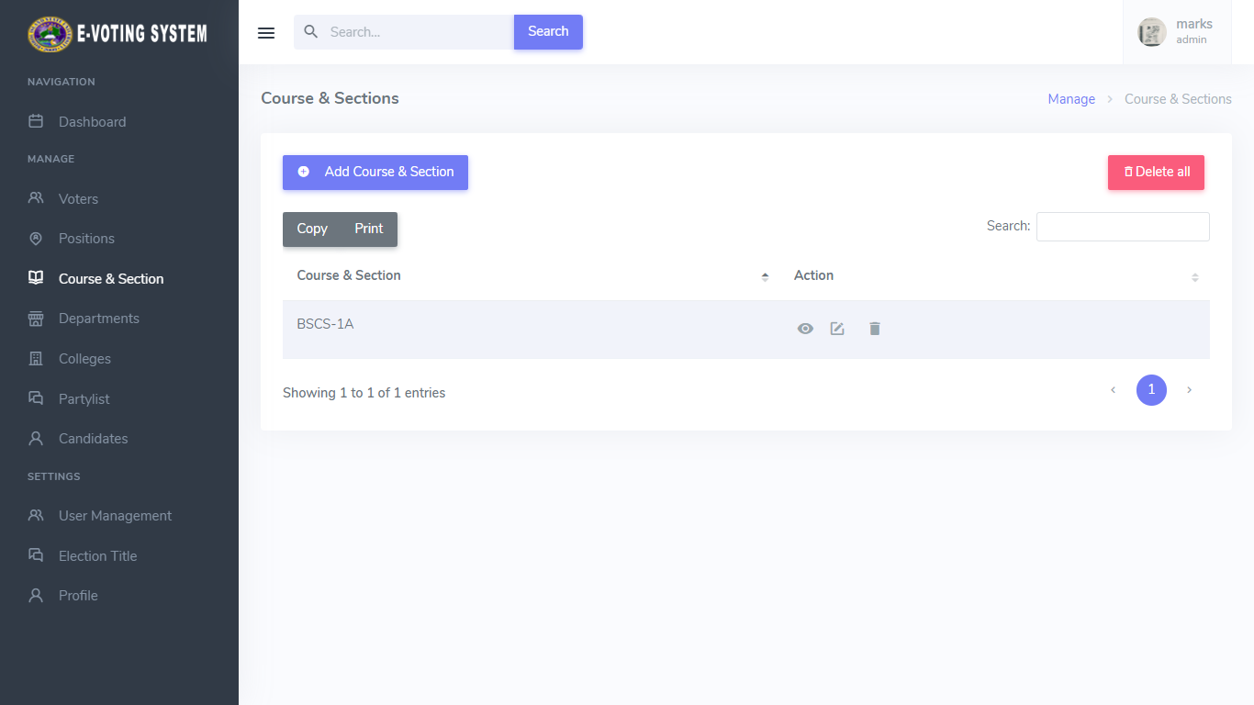

Preview 12. List of All Voter’s Course and Section

The preview below shows the Update Form of Voter’s Course and Section

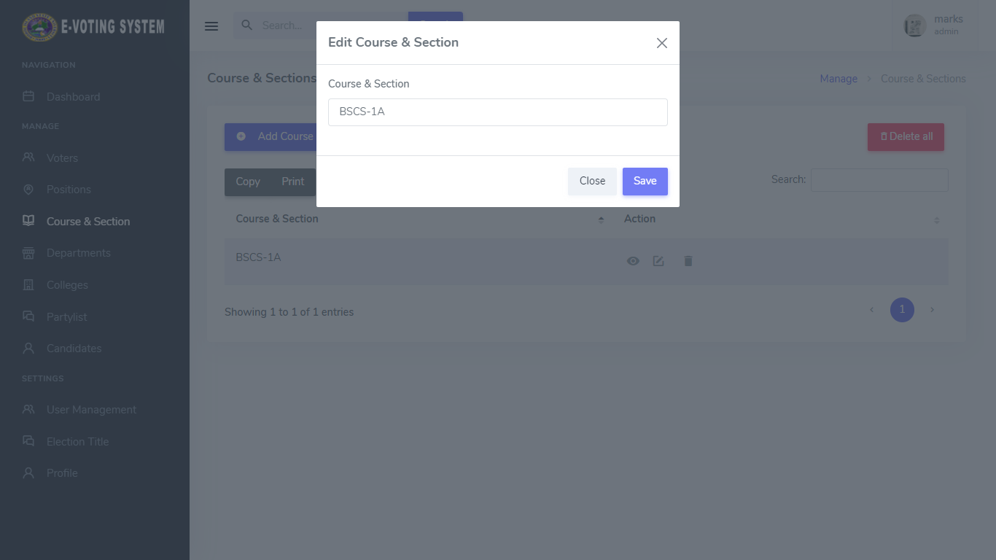

Preview 13. Update Form for Voter’s Course and Section

The preview below shows the adding of Voter’s Department

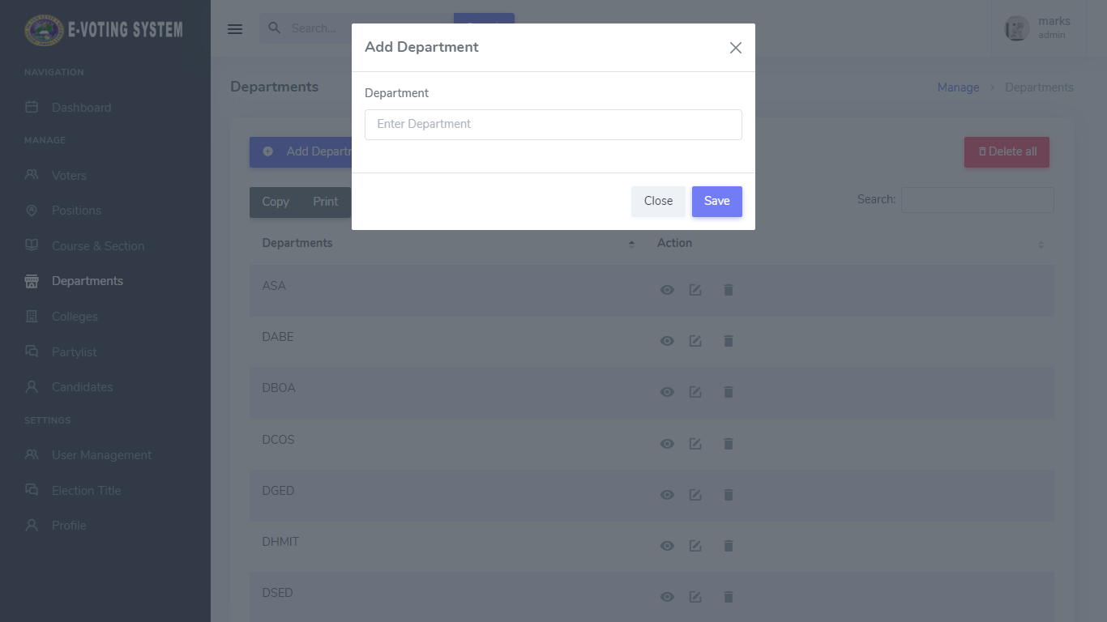

Preview 14. Adding Voter’s Department Form

The preview below shows the List of All Voter’s Department

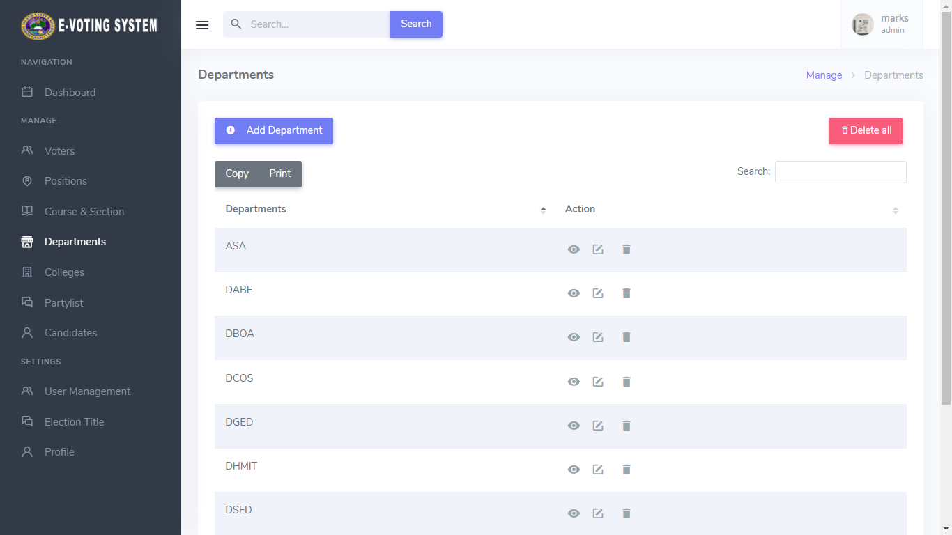

Preview 15. List of All Voter’s Department

The preview below shows the Update Form of Voter’s Department

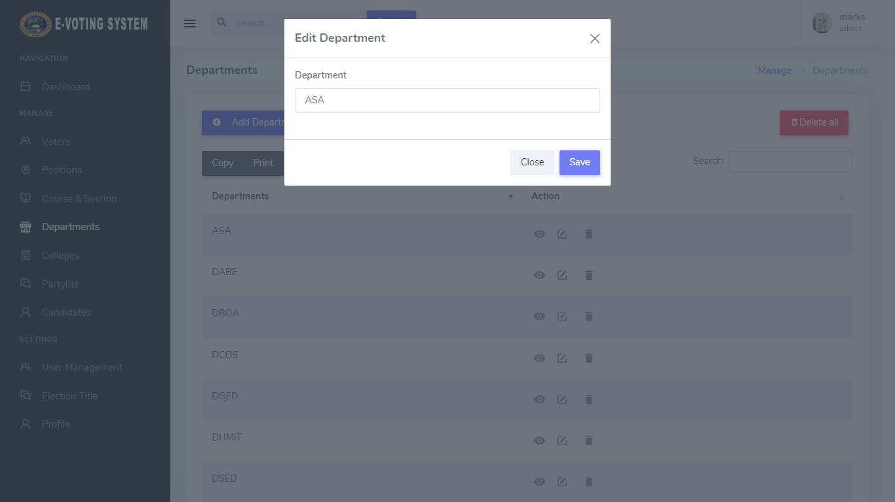

Preview 16. Update Form for Voter’s Department

The preview below shows the adding of Voter’s College

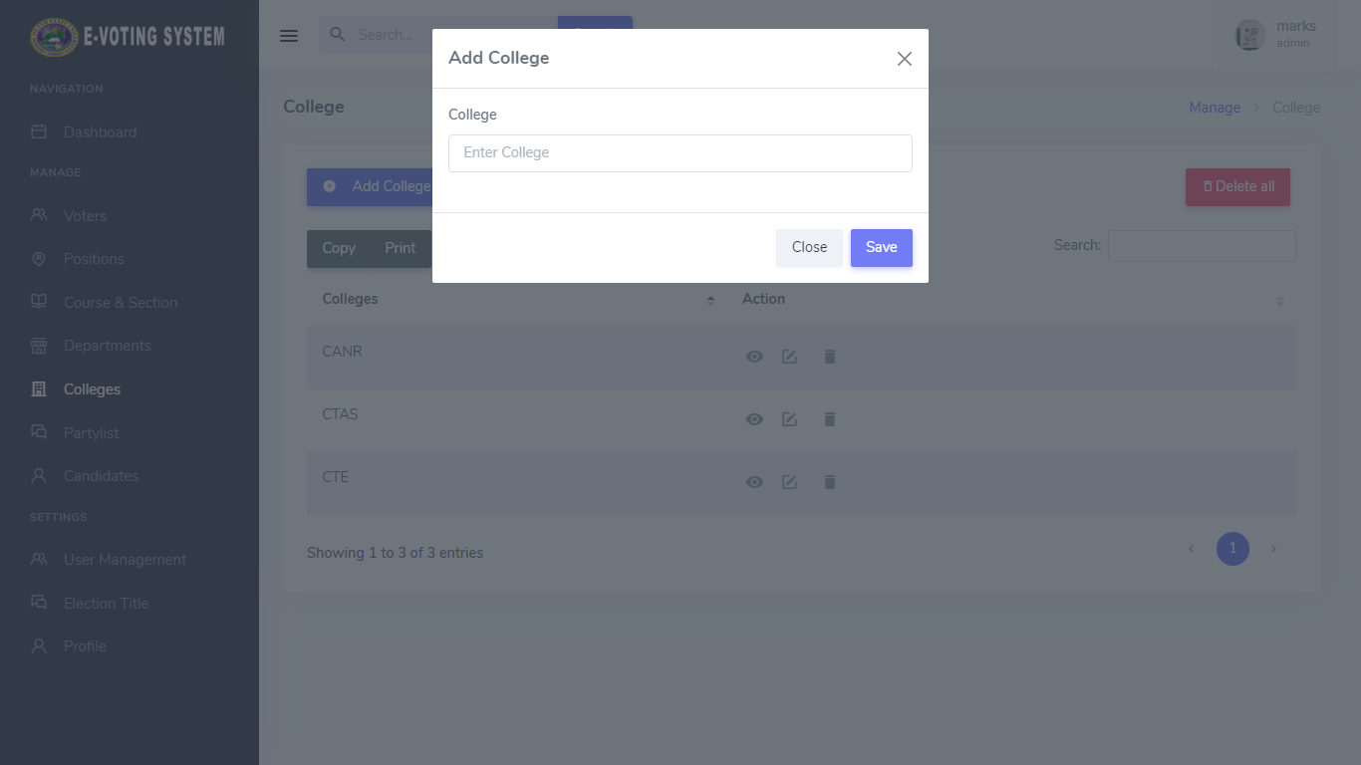

Preview 17. Adding Voter’s College Form

The preview below shows the List of All Voter’s College

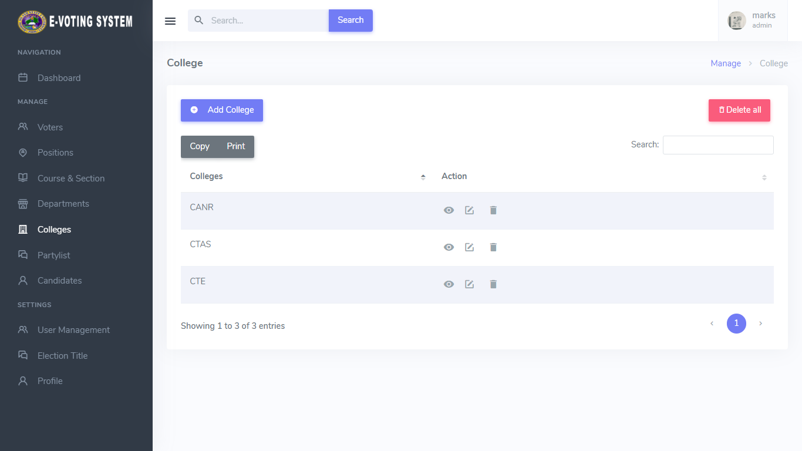

Preview 18. List of All Voter’s College

The preview below shows the Update Form of Voter’s College

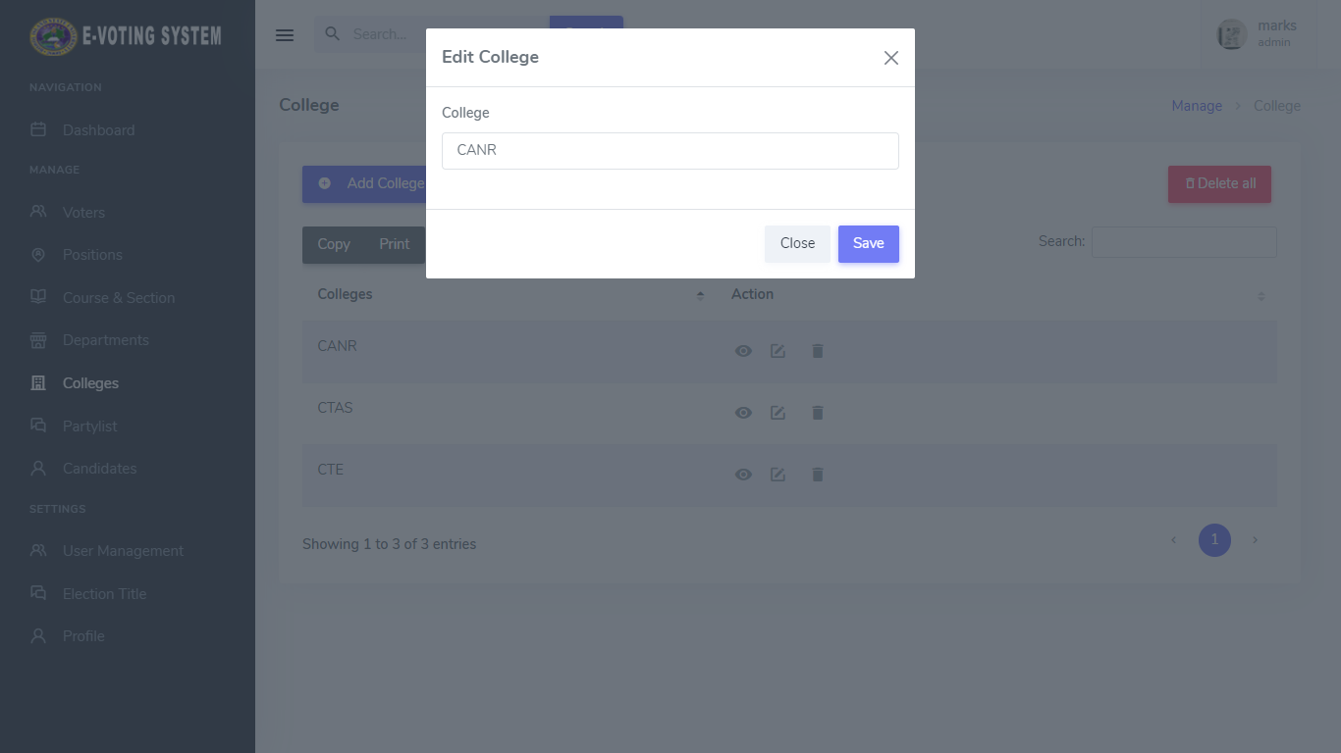

Preview 19. Update Form for Voter’s College

The preview below shows the adding of Candidate’s Partylist

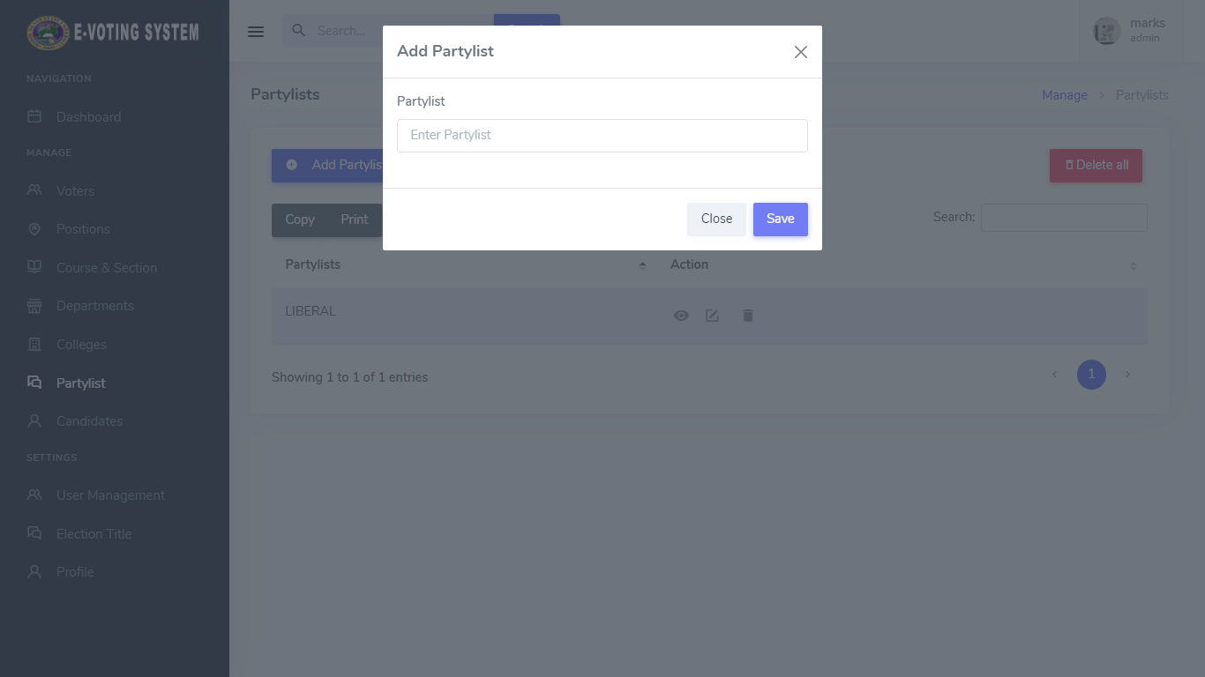

Preview 20. Adding Candidate’s Partylist Form

The preview below shows the List of All Candidate’s Partylist

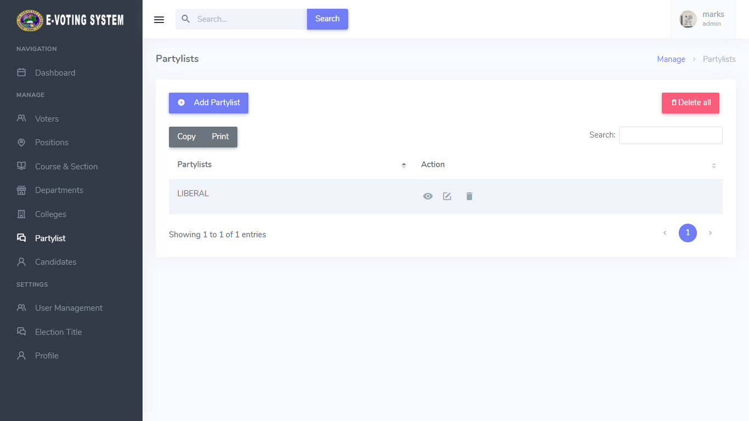

Preview 21. List of All Candidate’s Partylist

The preview below shows the Update Form of Candidate’s Partylist

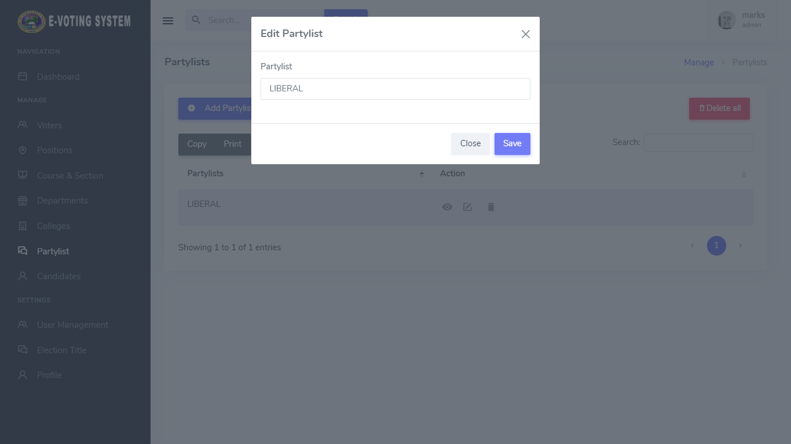

Preview 22. Update Form for Candidate’s Partylist

The preview below shows the adding of Candidate

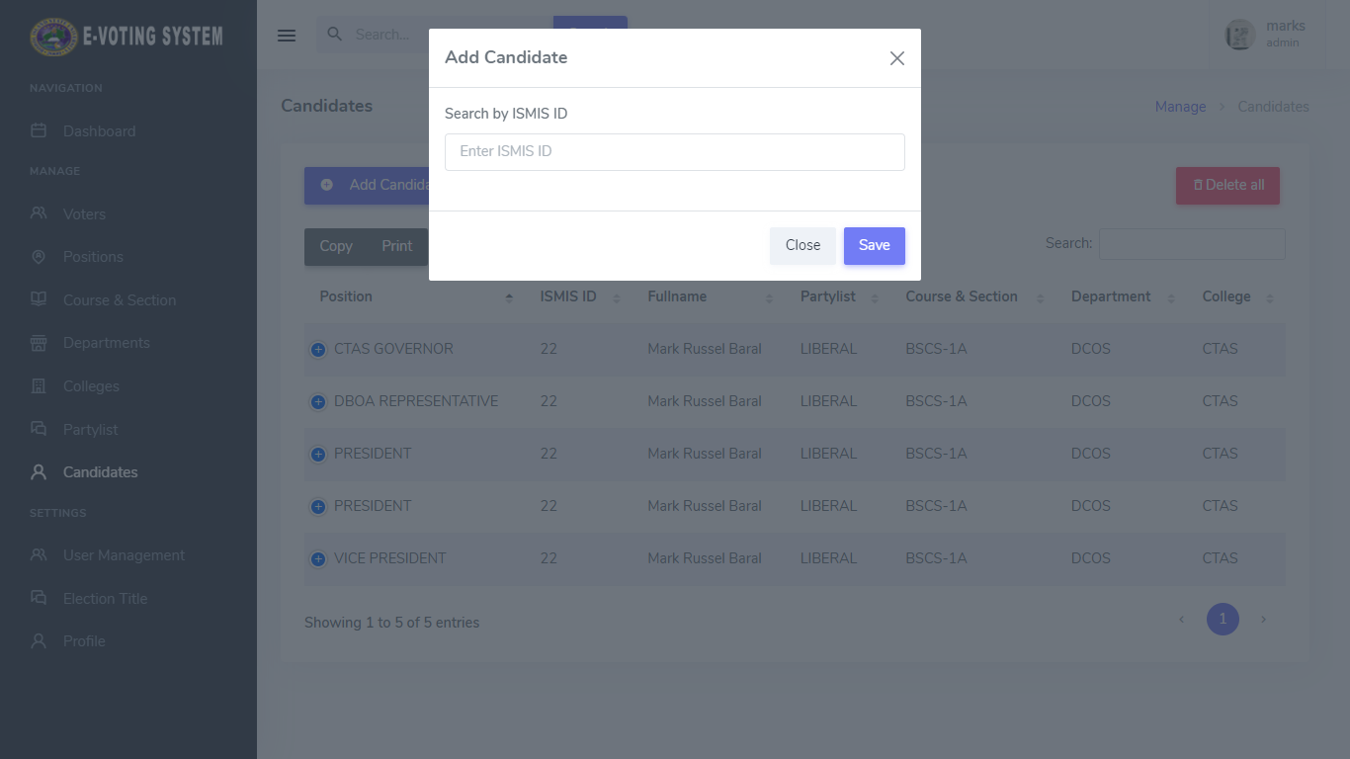

Preview 23. Adding Candidate Form

The preview below shows the List of All Candidates

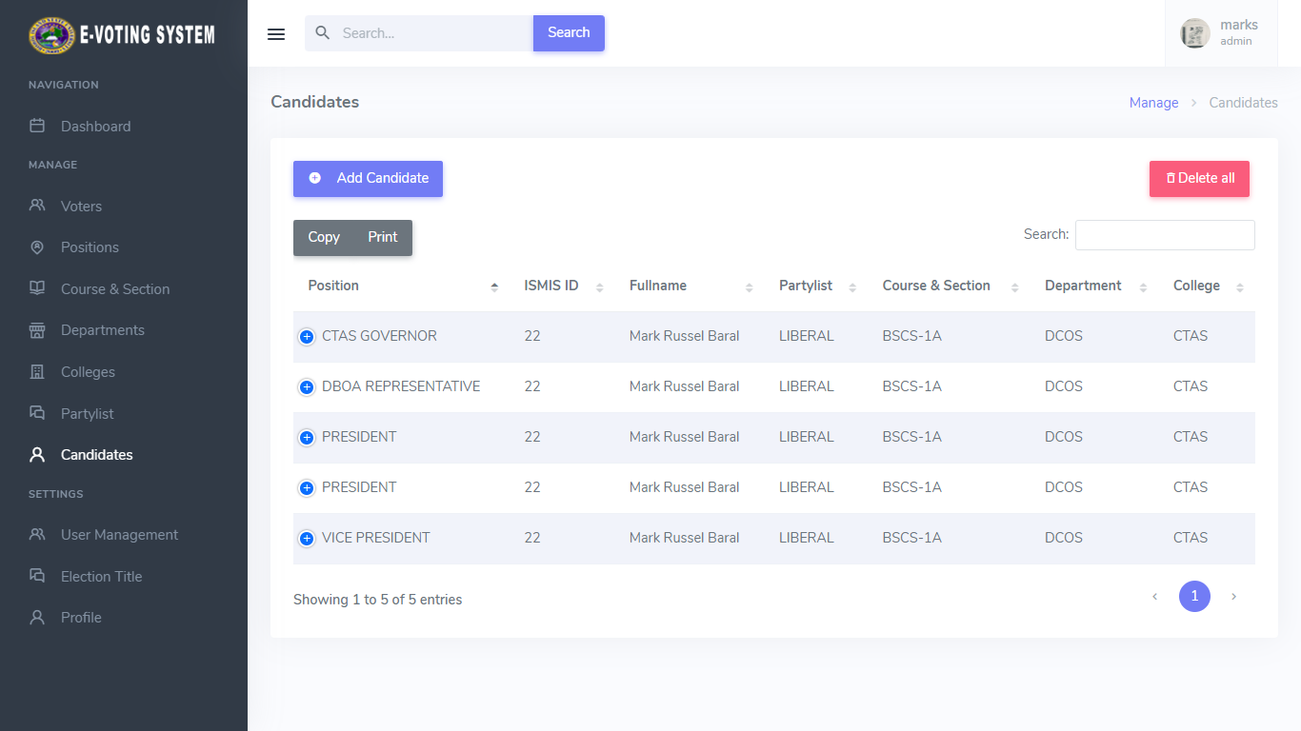

Preview 24. List of All Candidates

The preview below shows the Update Form of Candidates

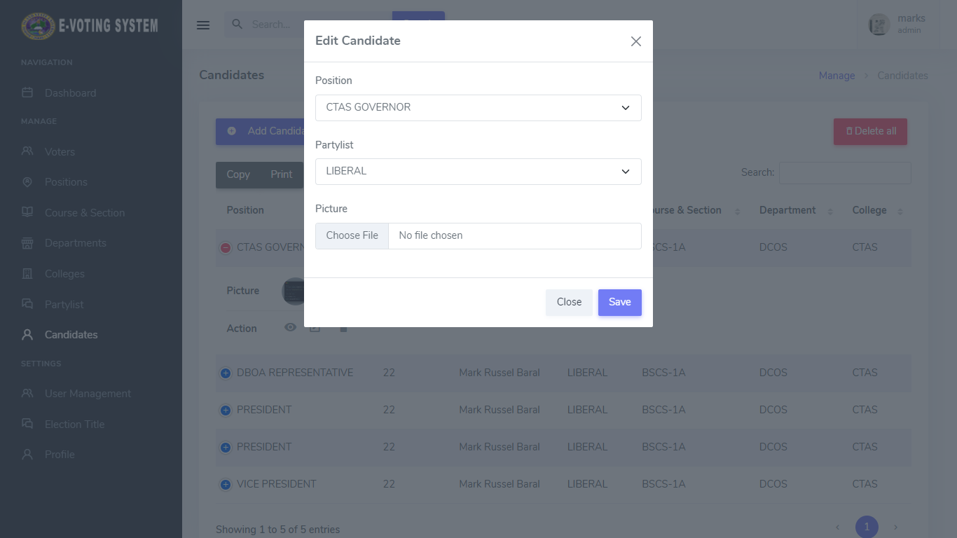

Preview 25. Update Form for Candidates

The preview below shows the adding of User

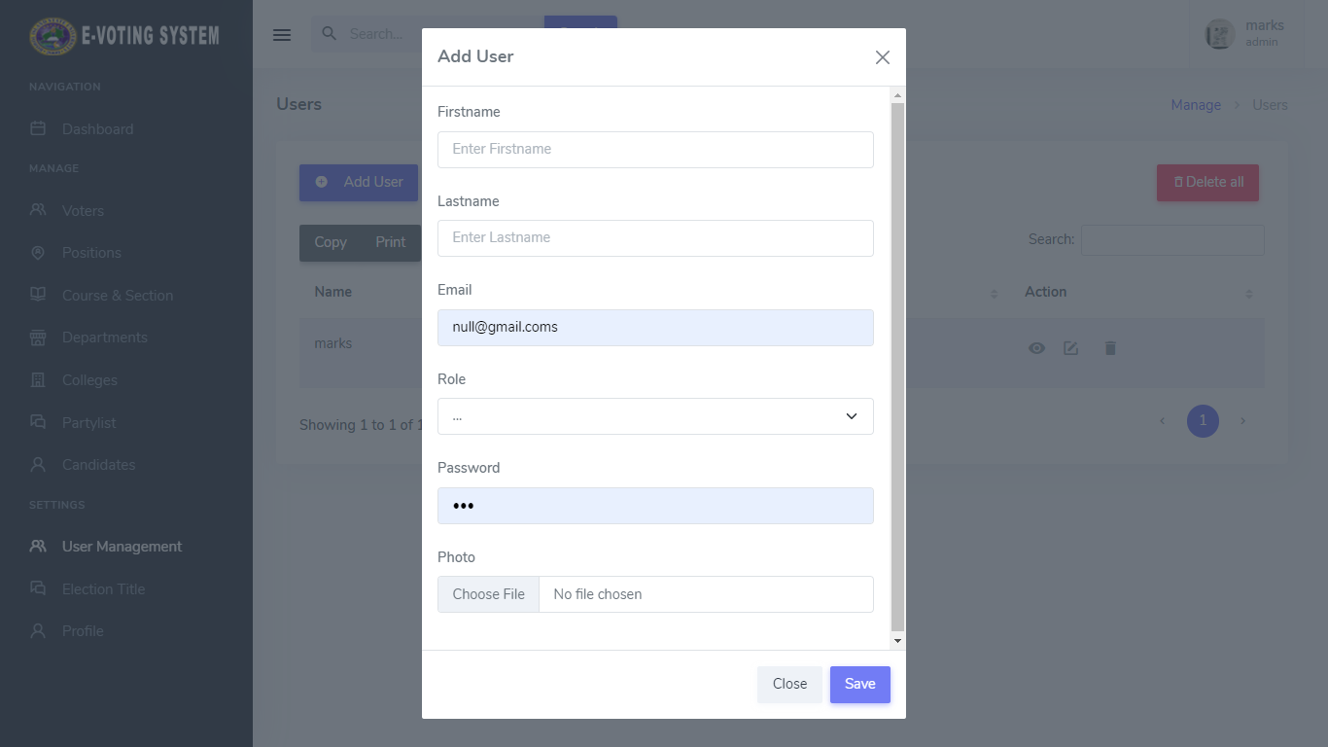

Preview 26. Adding User Form

The preview below shows the List of All Users

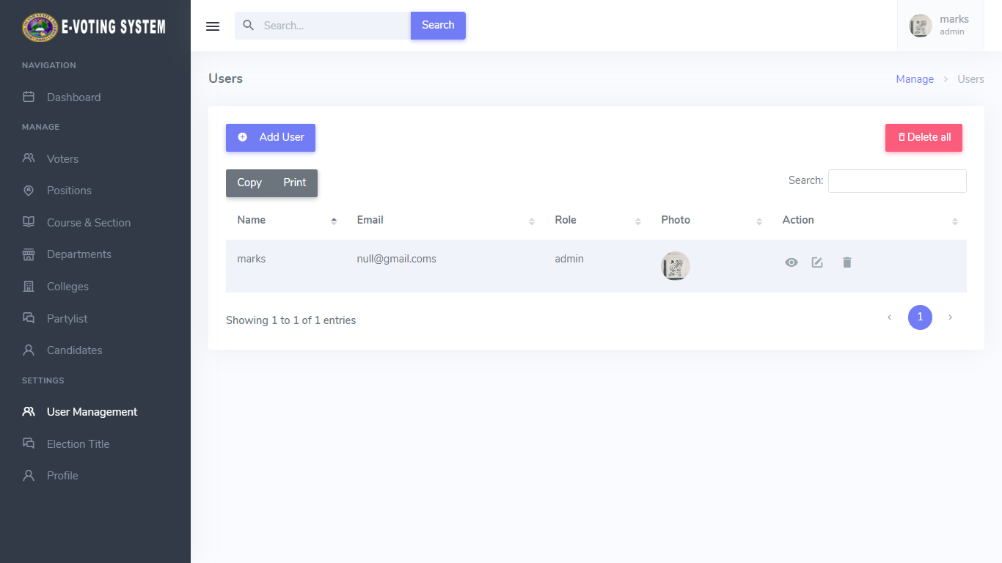

Preview 27. List of All Users

The preview below shows the Update Form of Users

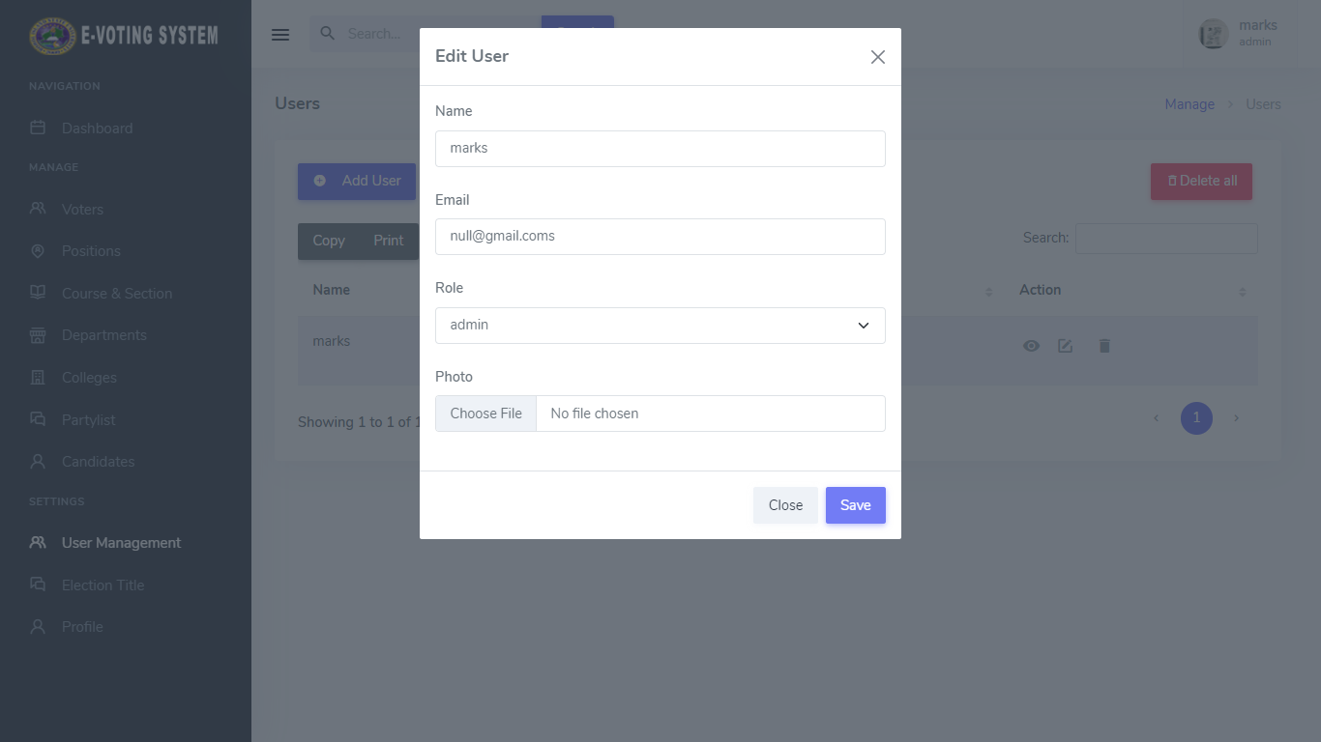

Preview 28. Update Form for Users

The preview below shows the Election Title and Start Election

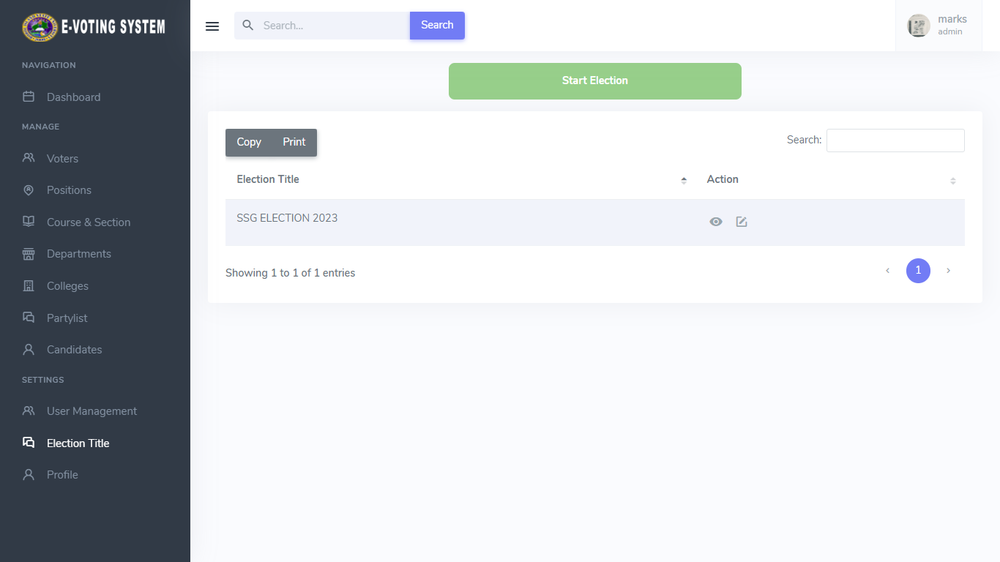

Preview 29. Election Title and Start Election

The preview below shows the Update Form of Election Title

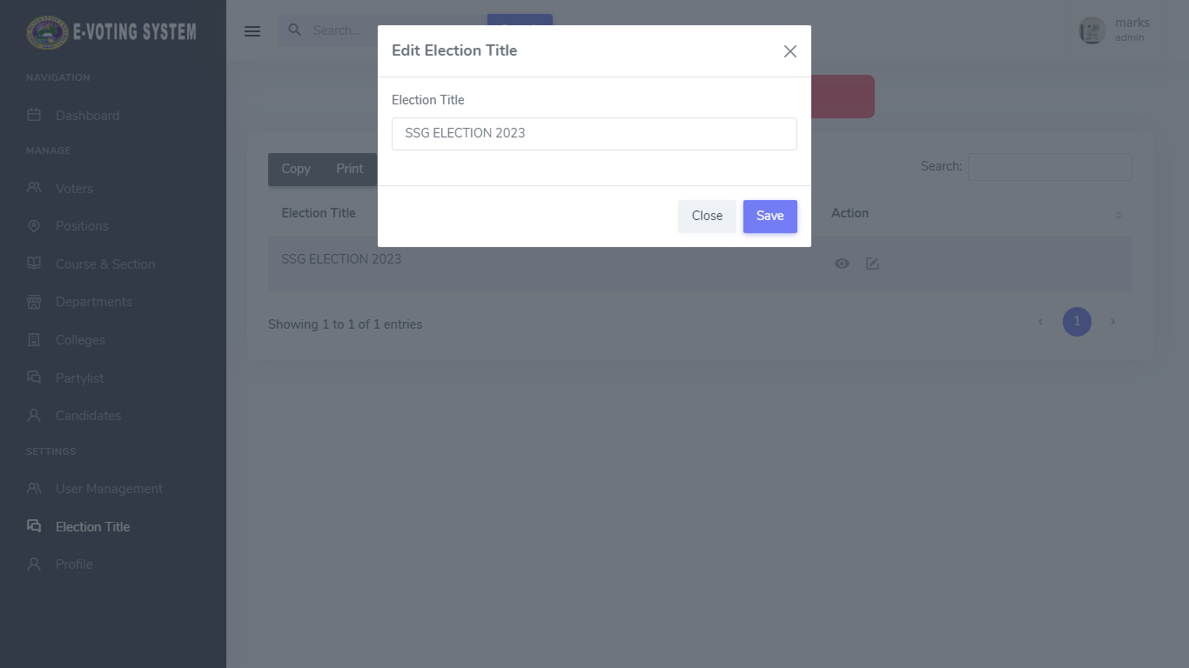

Preview 30. Update Form for Election Title

The preview below shows the Stop Election

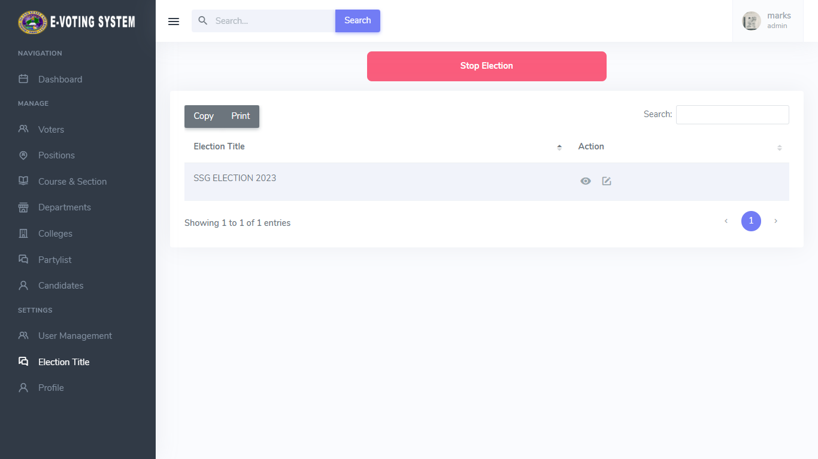

Preview 31. Stop Election

The preview below shows the User’s Profile and Personal Info

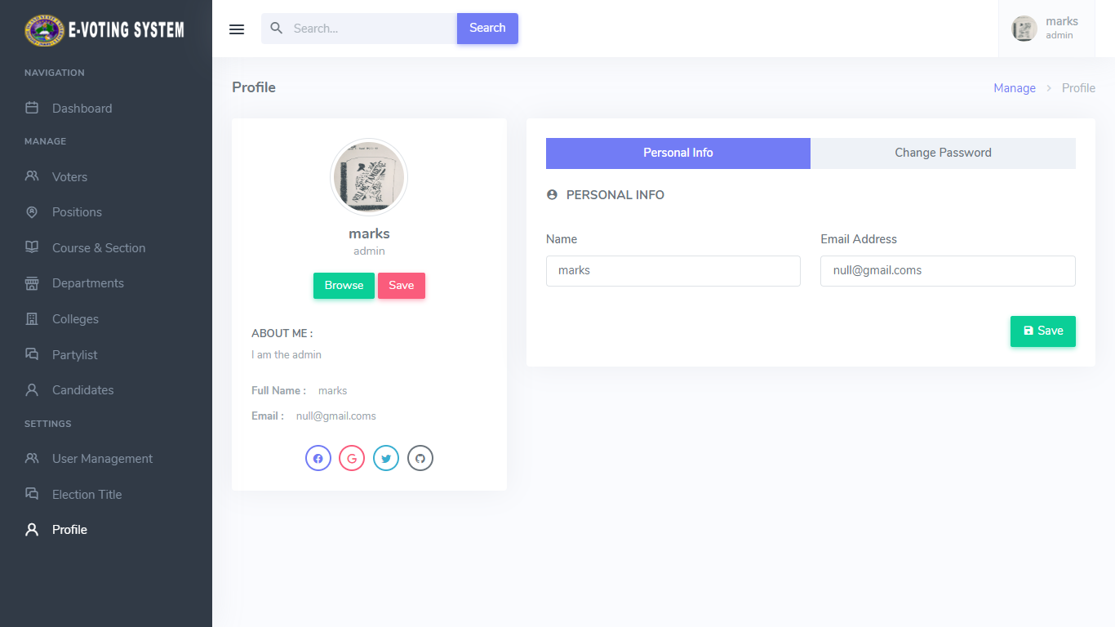

Preview 32. User’s Profile and Personal Info

The preview below shows the User’s Change Password

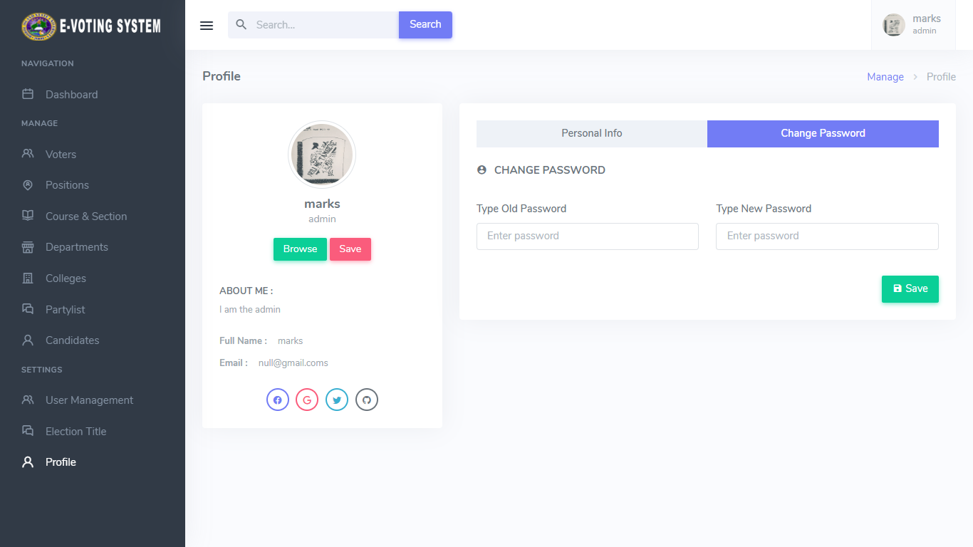

Preview 33. User’s Change Password

**Economic Performance Evaluation**

The economic performance of the SSG E – Voting System in Bohol Island State University Bilar Campus was evaluted in terms of initial investment and annual operating cost. The initial investment is the amount needed by the client prior to the commencement of the operation and implementation of the system while the annual operating cost is the total amount needed in one year of implementation. This includes the internet subscription cost, subscription for the domain, and web hosting maintenance, and other operation-related expenditures. Table 13 below presents te required investment and annual operating cost in the adoption of the system. Based on the result of the analysis, adopting the system requires the total amount of **P102,953** for the first year of implementation.

The estimated amount would give the client an idea whether they would adopt the computerization or not.

Table 13

Initial Investment and Annual Operating Cost

|  |  |  |  |  |  |  |  |  |  |  |
| --- | --- | --- | --- | --- | --- | --- | --- | --- | --- | --- |
| **Item** | **Qty** | | | | **Unit** | | **Unit Price** | | | **Total** |
| **A. Initial Investment** | | | | | | | | | | |
| **A.1. Hardware** | | | | | | | | | | |
| Desktop Computer  Printer  UTP Cable  RJ45 | 1  1  7  10 | | | | Set  Set  Meter  Pieces | | 30,000.00  10,000.00  20.00  10.00 | | | P30,000.00  10,000.00  140.00  100.00 |
| **Subtotal** |  | | | |  | |  | | | **P40,240.00** |
| **A.2. Software** | | | | | | | | | | |
| Software  Software Development  Software Installation |  | | | |  | | 20,000.00  6,000.00  1,000.00 | | | P20,000.00  6,000.00  1,000.00 |
| **Subtotal**  **TOTAL** | | | | | | | | | | **P27,000.00** |
| **P67,240.00** |
| **A. Annual Operating Cost** | | | | | | | | | | |
| **B.1. Subscription** | | | | | | | | | | |
| Internet  Domain and Web Hosting | | 12  1 | | Months  Year | | | 1,300.00  8,000.00 | | P15,600.00  P8,000.00 | |
| **Subtotal** | | | | | | | | | **P23,600.00** | |
| **B.2. Office Supplies** | | | | | | | | |  | |
| Bond Paper  Folder  Fastener  Printer Ink cyan  Magenta  Yellow  Black | 5  7  7  6  2  2  2 | | Reams  Pieces  Pieces  Pieces  Pieces  Pieces  Pieces | | | 170.00  6.00  3.00  300.00  300.00  300.00  300.00 | | | P850.00  42.00  21.00  1,800.00  600.00  600.00  600.00 | |
| **Subtotal** | | | | | | | | | **P4,513** | |
| **Total** | | | | | | | | | **P28,113** | |
| **B. Utilities** | | | | | | | | | | |
| Electricity | 12 | | Months | | | 300.00 | | | 3,600.00 | |
| **C. General Services** | | | | | | | | | | |
| System Maintenance | 4 | | Quarter | | | 1,000.00 | | | 4,000.00 | |
| **Total** | | | | | | | | | **P7,600.00** | |
| **GRAND TOTAL** | | | | | | | | **P102,953.00** | | |

**Testing and Evaluation**

System testing of the application is usually done through the complete application software to evaluate the software’s overall compliance with the business, functional, and end-user requirements. In system testing, a software test professional aims to detect defects or bugs both within the interfaces and also within the software as a whole. However, during the integration testing of the application or software, the tester aims to detect bugs or defects between the individual units were integrated. During system testing, the focus is on the software design, behavior and even the believed expectations of the customer. Thus, a significant aspect of the design should be developed to ensure that the artifact meets the specified requirements, that is , the evaluation of the system. Sytem usability was used as a parameter is this study

**REFERENCES**

Alhari, M. I., Lubis, M., & Budiman, F. (2022, November). Information SystemManagement of Palm Agriculture using Laravel Framework. In *2022 International Conference on Informatics, Multimedia, Cyber and Information System (ICIMCIS)* (pp. 478-483). IEEE.

Aruna, T., & Kalaiselvi, C. (2018). VISITOR MANAGEMENT SYSTEM USING LARAVEL PHP. *International Research Journal of Engineering and Technology (IRJET)*, *5*(8).

Azran, N. Z. A. Z., & Wahid, N. (2022). Design and Development of a Web-Based System using Laravel Framework: A Competition Management System. *Applied Information Technology And Computer Science*, *3*(2), 514-532.

Celestine, H. C., Okeke, C. K., & Oye, N. D. (2018). E-Voting System for National Association of Computer Science Students Modibboadama University of Technology Yola, Adamawa State, Nigeria. *International Research Journal of Innovations in Engineering and Technology*, *2*(5), 12.

Hjálmarsson, F. Þ., Hreiðarsson, G. K., Hamdaqa, M., & Hjálmtýsson, G. (2018, July). Blockchain-based e-voting system. In *2018 IEEE 11th international conference on cloud computing (CLOUD)* (pp. 983-986). IEEE.

Khan, K. M., Arshad, J., & Khan, M. M. (2018). Secure digital voting system based on blockchain technology. *International Journal of Electronic Government Research (IJEGR)*, *14*(1), 53-62.

MatTaib, A., Shukri, N. A. M., Zukri, N. H. A., & Ghazali, N. (2020). Smart final year project archive system using Laravel Framework with email notification (SFYPAS). *Journal of Computing Research and Innovation*, *5*(2), 41-53.

Makungu, C., Munyao, R. M., & Mwai, J. K. (2018). Student online voting system. *Int. J Social Sci. Inf. Technol*, *4*(5), 175-196.

Patil, H. V., Rathi, K. G., & Tribhuwan, M. V. (2018). A study on decentralized e-voting system using blockchain technology. *Int. Res. J. Eng. Technol*, *5*(11), 48-53.

Sheela, A. S., & Franklin, R. G. (2021, March). E-voting system using homomorphic encryption technique. In *Journal of Physics: Conference Series* (Vol. 1770, No. 1, p. 012011). IOP Publishing.

Sulaiman, M. M. K. M. M., Othman, M. F. I., Shah, W. M., Hassan, A., Harum, N.,& Alseadoon, I. M. (2021). An Online Voting System using Face Recognition for Campus Election. *Journal of Advanced Computing Technology and Application (JACTA)*, *3*(1), 39-46.

Suralkar, S., Udasi, S., Gagnani, S., Tekwani, M., & Bhatia, M. (2019). E-Voting Using Blockchain With Biometric Authentication. *International Journal of Research and Analytical Reviews*, *6*(1), 72-81.

Teresa, G. G., & Cui, L. Mobile-based Student Council Voting System Case of Federal Technical Institute (FTI).

Vivek, S. K., Yashank, R. S., Prashanth, Y., Yashas, N., & Namratha, M. (2020, August). E-voting system using hyperledger sawtooth. In *2020 International Conference on Advances in Computing, Communication & Materials (ICACCM)* (pp. 29-35). IEEE.

Zuhdi, M. I. H., Subiyanto, S., & Sukamta, S. (2017). Management information systems of laboratory using laravel framework: case study at electrical engineering of Universitas Negeri Semarang. *Jurnal Pendidikan Vokasi*, *7*(2), 158-167.

Web page

Ali, I. (2022, June 23). An Overview of the Best Laravel Security Practices.Cloudways. https://www.cloudways.com/blog/laravel-security/

**Interview Questions**

For SSG Adviser:

1. What are the process of voting in SSG election?

2. What are the needed data to register the voters?

3. What platform did you use in the SSG election?

4. How many positions in SSG election?

5. What are the needed data to register the candidates?

6. What are the needed reports after the election?

7. What are the problems that you encounter during SSG election?

8. How much alloted time during SSG election?

**Survey Questionnaire**

For SSG Adviser:

1. What is the platform used for voting in the SSG Election?

Using a ballot Using Google Forms Using a Voting System

1. Who is in-charge of the election? _________
2. What are the positions of SSG?

President Public Information Officer

Vice President Senators

Secretary College Governor

Treasurer College Vice-Governor

Auditor Department Representative

1. How many senators are elected every SSG election?

9 11

10 12

1. How many parties are part of the election?

1 2 3 and above

1. What are the needed data of the candidates for the election?

Name Section

Course Age

College Address

Department Partylist

Year

1. How many are the expected voters in the SSG Election?

3,000 4,000 5,000 and above

1. What is the alloted time for the election?

4 hours 8 hours 12 hours and above